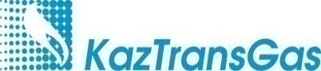
Annex
to the decision of the Board of Directors
of KazTransGas JSC
No. __ dated “___” ______ 2019

Annual report of KazTransGas JSC
for 2018

Nur-Sultan
2019
Table of content
4 Address to the Shareholders
6 About the Company
6 Assessment of KazTransGas JSC position and its development prospects based on the results of 2018
10 Events of 2018
13 Strategic goals of KazTransGas JSC Company Group
14 Financial and operational performance indicators of KazTransGas JSC Company Group
14 Main production and financial indicators in terms of subsidiaries and affiliates
20 Investment activities
29 Innovations
31 Interested party transaction of KazTransGas JSC
31 Asset structure
31 Main directions of development
32 Risk management
35 Integrated Management System
41 Health, Environment and Safety
45 Social responsibility
48 Corporate governance
50 Interaction with the Shareholder
50 Interaction with subsidiaries and affiliates
54 Sustainable development
55 Local content (LC) in the procurement of KazTransGas JSC Company Group
56 Corporate security
58 Credit ratings and debt portfolio management
60 Independent auditor's report
66 Consolidated financial statements
71 Report on compliance with the principles of the Corporate Governance Code of KazTransGas JSC in 2018
75 Glossary

Address to the Shareholders
Dear shareholders and partners of KazTransGas JSC!
KazTransGas Joint-Stock Company is a part of the KazMunayGas NC JSC Company Group. The national gas operator operates the largest gas pipeline network in Central Asia with a total length of more than 19 thousand km with an annual throughput capacity of up to 230 billion cubic meters and gas distribution networks with a length of more than 47 thousand km.
Daily, the company's employees ensure the smooth operation of 40 compressor plants, which have 348 gas pumping units installed, serve 3 underground gas storages with a total active storage capacity of 4.6 billion cubic meters.
KazTransGas JSC is the main gas supplier to the domestic market of the Republic of Kazakhstan, providing more than half of the country's population with marketable gas. It should be noted that in recent years, the company has carried out extensive work on upgrading and building gas transmission infrastructure and distribution networks in various areas of the country. In the past five years alone, more than three million Kazakhstanis were able to use gas, the gasification level of the population increased from 30% in 2013 up to 49.68% in 2018 and amounted to more than 9 million citizens. The number of gasified domestic enterprises increased significantly from 23,725 up to 44,189, or by 86%.
Last year, the domestic gas industry celebrated its 60th anniversary and to this anniversary KazTransGas came with record high production and financial indicators. Consolidated income of KazTransGas JSC Company Group for 2018 amounted to KZT 1 trillion 061 billion, which is KZT 398.9 billion or 60% higher than in 2017. Consolidated profit before taxation of the National Operator Company Group amounted to KZT 201 billion, which is higher than in 2017 by KZT 102 billion or 103%.
In 2018, KazTransGas JSC paid taxes and other payments to the budget in the amount of more than KZT 99.5 billion, which once again confirms the status of the company as the largest taxpayer in the country.
The volume of gas sales for the reporting period amounted to 22.9 billion cubic meters. This is higher than in 2017 by 5.2 billion cubic meters or 29%. At the same time, in 2018, the agreement on gas export to China was fulfilled ahead of schedule and in full volume.
The volume of trunk transportation amounted to 111.9 billion cubic meters, which is higher than the 2017 figure by 11 billion cubic meters or 11%.
It should be noted that last year we celebrated 10 years since commissioning of one of the largest international projects - the Kazakhstan-China Main Gas Pipeline. By the Day of the First President and by the Day of Independence, KazMunayGas NC JSC and KazTransGas JSC put into operation the largest compressor plants in Central Asia - Aral, Turkestan and Korkyt Ata on the Beyneu-Bozoi-Shymkent Main Gas Pipeline. In addition, compressor plants No. 5 and No. 7 on the “C” line of the Kazakhstan-China gas pipeline were commissioned. Thus, the work on the formation of Kazakhstan-China transnational gas pipeline, which unites four states - Turkmenistan, Uzbekistan, Kazakhstan and China, was fully completed.
For ten years of its work Kazakhstan-China gas pipeline has shown not only its effectiveness, but also great economic and geopolitical importance for our states. An example is the contract signed last year on the supply of Kazakhstani gas for export to China of up to 50 billion cubic meters over 5 years.

We present more detailed information to your attention in the annual report on the activities of KazTransGas JSC for 2018. It summarizes not only main results and directions of production activities, but also formulates the principles of business, social and personnel policy.
We remain true to our mission - “To bring warmth and comfort to the houses of Kazakhstanis, to ensure the energy security of the country”. Today, the Kazakhstani gas industry occupies a leading position in the oil and gas sector, and all the results achieved by KazTransGas JSC make it possible to fulfill the instructions of the First President of the Republic of Kazakhstan - Yelbasy to increase the country's transport and transit potential and strengthen the energy security of Kazakhstan.

About the Company
KazTransGas Company was established in accordance with the Decree of the Government of the Republic of Kazakhstan dated February 5, 2000 No. 173. On June 9, 2004, in accordance with the Law of the Republic of Kazakhstan “On Joint-Stock Companies” dated May 13, 2003 No. 415-II, KazTransGas Closed Joint-Stock Company was renamed to KazTransGas Joint-Stock Company. Certificate of state re-registration of a legal entity No. 13898-1901-AO dated June 9, 2004 was issued by the Department of Justice of Astana.
The gas industry of the Republic of Kazakhstan has significant potential for further development, which will make it possible in the future to make Kazakhstan one of the leading producers of natural gas. KazTransGas JSC is the largest gas supplying company of the Republic of Kazakhstan, representing the interests of the state in the country's gas market and in the world.
The sole shareholder is KazMunaiGas National Company JSC. KazTransGas JSC manages the transportation of natural gas through trunk gas pipelines, is engaged in the extraction and sale of gas in the domestic and foreign markets, develops, finances, builds and operates pipelines and gas storages.
In accordance with the Decree of the Government of the Republic of Kazakhstan dated July 5, 2012 No. 914, KazTransGas Joint-Stock Company was designated as the national operator in the field of gas and gas supply.
In the reporting period, KazTransGas JSC Company Group included 10 subsidiaries and affiliates, which are represented in the following business areas:
- expansion of the resource base: Amangeldy Gas LLP, KMG Kansu Operating LLP;
- trunk transportation: Intergas Central Asia JSC, Asian Gas Pipeline LLP, Beineu-Shymkent Gas Pipeline LLP, KazTransGaz-Bishkek LLC;
- transportation through gas distribution systems: KazTransGas Aimak JSC;
- gas trading: KazTransGas Onimderi LLP, KazRosGaz LLP (50% share in trust management);
- other subsidiaries and affiliates: Intergas Finance B.V.

Assessment of KazTransGas JSC position and its development prospects based on the results of 2018
Today the gas industry of Kazakhstan and in the world is one of the most dynamically developing in comparison with oil and coal. Expanding opportunities for its application put it together with alternative energy sources in one row of the main energy sources in the future.
According to BP, Kazakhstan is ranked the 25th in the world (0.6% of total world reserves) and the 3rd among CIS countries after Russia and Turkmenistan for explored reserves of natural gas (1.1 trillion m3), in gas reserves. Approved recoverable reserves are 4 trillion m3, including 2.2 trillion m3 of associated gas and 1.8 trillion m3 of free gas.

Volumes of proven natural gas reserves by country, trillion. m³

The main part of gas resources in Kazakhstan is concentrated on large fields being developed or prepared for development, including oil fields - Tengiz, Kashagan, Korolevskoye (Atyrau oblast), gas condensate oil fields - Karachaganak (West Kazakhstan oblast), Zhanazhol, Urikhtau (Aktyubinsk oblast) and others.
Currently, Amangeldy Gas LLP, on the basis of the Contract for combined exploration and production of hydrocarbons dated December 12, 2000, continues to develop the Amangeldy group of gas fields in Zhambyl oblast.
Recoverable reserves of natural gas as of 01.01.2019 make up: on Amangeldy field -8,425.8 million cubic meters, on Zharkum field - 367.1 million cubic meters, and on Ayrakty field - 5,189.3 million cubic meters.
However, in terms of gas reserves and volumes, the position of KazTransGas JSC in the market of the Republic of Kazakhstan is weak, and its share is about 1-2%.
21 subsoil users are connected to the Unified Gas Supply System (hereinafter - UGSS). In this regard, KazTransGas JSC in order to ensure the energy security of the Republic of Kazakhstan, sees a critical task to connect the subsoil users extracting associated petroleum gas to the UGSS.
The gas sector development concept of the Republic of Kazakhstan until 2030 defines the vision and the main approaches to the phased reforming and integrated development of the gas sector of the Republic of Kazakhstan provides for significant potential in Kazakhstan in terms of exploration and production of coal bed methane in addition to traditional gas resources. In pursuance of the updated Action Plan (Road Map) approved by the Minister of Energy of the Republic of Kazakhstan in September 2016 for the implementation of the order of the President of the Republic of Kazakhstan, N. Nazarbayev, regarding arranging exploration and production of coal bed methane, KazTransGas JSC is conducting work on the geological exploration of coal bed methane within the innovative investment project “Coal methane recovery from the Karaganda coal basin”.
One of the promising transit directions for Kazakhstan is Kazakhstan-China MGP with a throughput capacity of 55 billion cubic meters/year. Today it is the largest investment project in the oil and gas industry of the country.
Gas transportation includes a system of main gas pipelines (MGP), underground gas storage facilities (UGSF), and also distribution gas pipelines.
In total, KazTransGas JSC Company Group operates gas pipelines with a total length of about 66 thousand km, including about 19 thousand km of main gas pipelines and more than 47 thousand km of distribution gas pipelines.
At present, 10 of 14 oblasts (regions) of the Republic of Kazakhstan are gasified, mainly regional centers. The gasification coverage rate of the population of the Republic of Kazakhstan in 2018 was 49.68%.

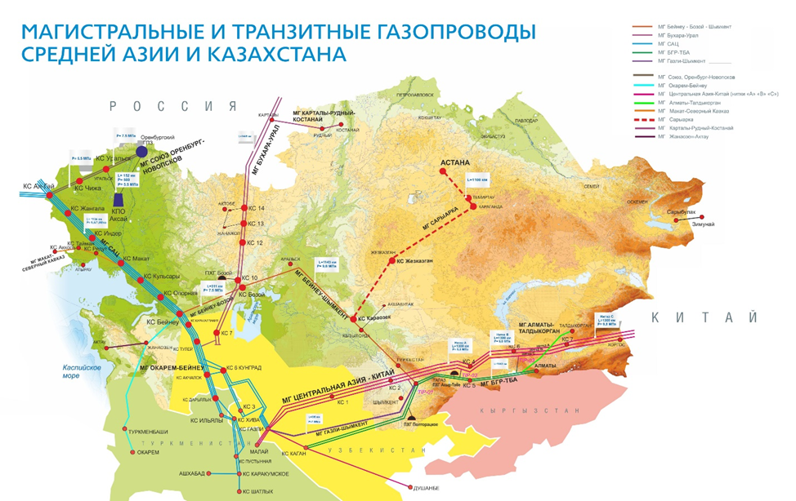
MAIN AND TRANSIT GAS PIPELINES
OF THE CENTRAL ASIA AND KAZAKHSTAN

The approved General Gasification Scheme for 2015–2030 is aimed at creating conditions for meeting the domestic gas needs of Kazakhstan not only through the large-scale construction of new gas pipelines, but also by searching for alternative and rational sources of gas supply to the republic’s regions. In addition, as a part of stimulating and developing gasification of the regions with compressed natural gas, incentive measures will be provided for vehicles using gas as a motor fuel.
Based on the principles of multi-vector supply of hydrocarbons to domestic and foreign markets, Kazakhstan seeks to develop all economically advantageous routes for transit and export supplies of natural gas. At the same time, it remains important to maintain an endorsed energy policy with neighboring countries, since transit-export routes pass through their territories.
Taking into account the growth of domestic consumption and significant volumes of re-injection, the export gas potential of Kazakhstan is not so significant yet. A significant increase in export deliveries is possible, for example, by reducing the volume of gas re-injection, which, however, has not been envisaged yet by the field exploration flow diagrams.
The share of KazTransGas JSC in the field of gas and gas supply in Kazakhstan in 2018 is presented in the table below.
Name | Marketable gas production | Supply to the domestic market | Import | Export
Republic of Kazakhstan, billion m³ | 33,3 | 16,1 | 6,1 | 18,9
KazTransGas JSC, billion m³ | 0,3 | 14,9 | 6,1 | 8,9
Share of KazTransGas, % | 0,9 | 92,5 | 100,0 | 47,1

In accordance with the Law “On Gas and Gas Supply”, marginal wholesale prices for marketable gas are approved annually by the Ministry of Energy of the Republic of Kazakhstan in coordination with the Ministry of National Economy of the Republic of Kazakhstan.
In 2018, wholesale prices for marketable gas for the period from July 1, 2018 to June 30, 2019, including an increase of 6.6-10% in the southern regions (Almaty and Almaty oblast, Shymkent and Turkestan oblast, Zhambyl oblast) were approved by the order of the Minister of Energy of the Republic of Kazakhstan of May 15, 2018 No. 188.
In accordance with the minutes of the meeting on gas pricing in the southern region of the country dated June 22, 2018, chaired by the Prime Minister of the Republic of Kazakhstan, B.A. Sagintayev, marginal wholesale prices for gas in the southern regions are kept at the same level approved by order of the Minister of Energy of the Republic of Kazakhstan dated May 5, 2017 No. 164.
Following the results of the meeting of the Security Council of the Republic of Kazakhstan on November 7, 2018, the Ministry of Energy of the Republic of Kazakhstan adopted the order “On making amendments and supplements to the order of the Minister of Energy of the Republic of Kazakhstan “On approval of marginal wholesale prices of marketable gas in the domestic market” dated May 15, 2018 No. 188” dated December 10, 2018 No. 490.
According to the aforementioned order, wholesale prices for marketable gas were reduced for the period from January 1, 2019 to June 30, 2019 in the republic by an average of 11% (from 3.8% in Shymkent and Turkestan Oblast to 17.5% in Almaty and Almaty oblast).

Events of 2018

- Intergas Central Asia JSC was determined as the national operator for the main gas pipeline by the Decree of the Government of the Republic of Kazakhstan dated June 15, 2018 No. 353.
- On September 13, 2018 pursuant to the Decree of the Government of the Republic of Kazakhstan “On some issues of privatization for 2016–2020”dated December 30, 2015 No. 1141 a contract of sale of 100% of KazTransGas-Tbilisi LLC between KazTransGas JSC and Waltbay LTD.
- In accordance with the Action Plan (Road Map) for the implementation of five social initiatives of the President of the Republic of Kazakhstan, approved by the order of the Minister of Energy of the Republic of Kazakhstan dated March 12, 2018 No. 94 and by the decision of the Board of Directors of KazTransGas JSC dated May 14, 2018 No. 9 clause 2, contracts of sale and purchase of 100% shares in AstanaGas KMG JSC were concluded between KazTransGaz JSC, Samruk-Kazyna JSC and Baiterek Venture Fund JSC.
- On October 12, 2018, KazTransGas JSC and the authorized organization PetroChina International Company Limited signed a 5-year contract providing for an increase in the export of Kazakhstani gas to China from 5 billion cubic meters to 10 billion cubic meters per year.
- In the period from July to November 2018, compressor plants No. 5, No. 7 of the SCADA system and telecommunications of the C-line of Kazakhstan-China MG were commissioned. Commissioning of the third line of the gas pipeline (C line), the capacity of the Kazakhstan-China MG was increased to 55 billion m3 per year.

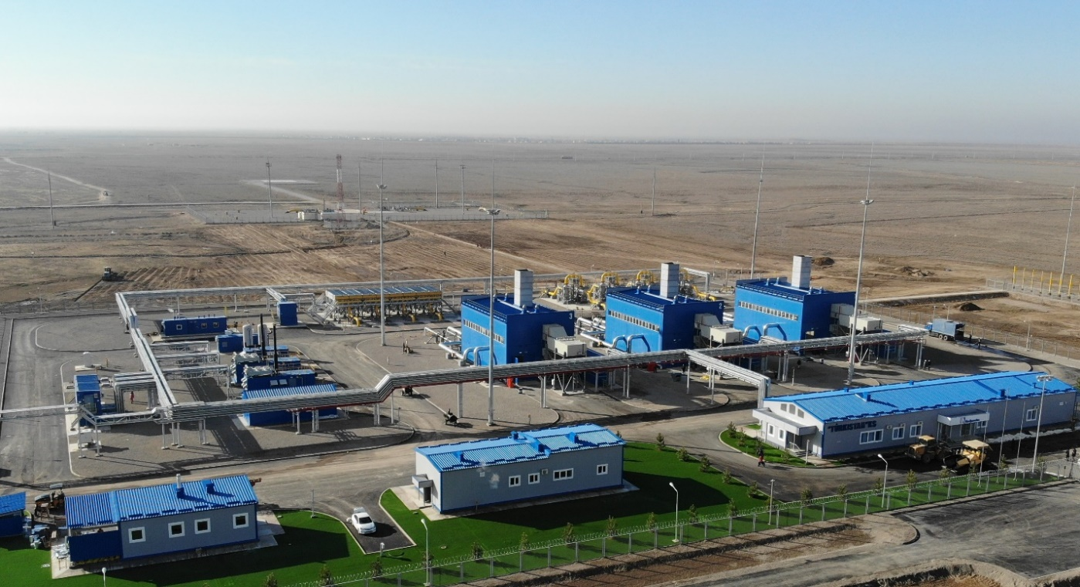

- On December 11, 2018, Intergas Central Asia JSC won the grand prix of the competition for social responsibility of business “Paryz” in the nomination “For contribution to the environment.”
- On December 11, 2018, a modern gas processing complex was put into operation in Baiganinskiy region of the Aktobe oblast at the Kozhasai field. As a part of this project, the National Operator KazTransGas JSC has built a main gas pipeline 168 km long from Kozhasai field to KS-12 Bukhara-Ural MG.
- Within measures to increase the troughput capacity of the Beineu-Bozoi-Shymkent gas pipeline from 10 billion m3 up to 15 billion m3 per year in December 2018, construction of three compressor plants - Turkestan, Aral, and Korkyt-Ata was completed.
- On December 20, 2018, Asian Gas Pipeline LLP repaid a bank loan in the amount of USD 800 million, of which USD 500 million ahead of schedule, which reduced the loan maturity by two years. To date, the amount of debt on two loans received for the implementation of the project “Construction of the Kazakhstan-China Main Gas Pipeline is USD 5.2 billion out of USD 10.2 billion received initially.
- Design-estimate documentation for the construction of Saryarka MGP was transferred in accordance with the sale and purchase agreement dated December 28, 2018 concluded between KTG and AstanaGas KMG JSC (the state expertise’s approval for the project was received on August 18, 2018).
- On December 29, 2018, Intergas Central Asia JSC and Uztransgaz JSC for the first time signed a contract for transportation of Uzbek natural gas through the territory of the Republic of Kazakhstan, within which on December 31, 2018, transit deliveries began through the Gazli-Shymkent and BGR-TBA Main Gas Pipelines. The contract provides for transportation of up to 1 billion m3 of Uzbekistani gas to consumers in Tashkent.
- KazTransGas JSC put into operation the Central Dispatch Unit in Kyzylorda on the Beineu-Bozoi-Shymkent Main Gas Pipeline. The CDU is a high-tech, computerized complex that performs the functions of collecting, processing and transmitting all the necessary information for the safe and reliable operation of BBSh MGP facilities.
- Within the state program «Digital Kazakhstan» the national gas operator began to apply blockchain technologies in the gas industry. They will be used for monitoring, servicing and repairing the gas transportation infrastructure and controlling gas meters.
- KazTransGas JSC exported 5 billion cubic meters of Kazakhstani gas in China one month ahead of the schedule. The contract on export of gas to China is executed ahead of the schedule and in full volume.
- S&P Global Ratings raised the rating of KazTransGas JSC to BB with a Stable outlook, after similar actions with respect to the parent company. In addition, S&P Global Ratings believes that with the growth in the number of trading operations, the significance of the company for the KMG Group is increased. Currently, the rating agency considers KTG as KMG subsidiary, which has “strategic importance”, taking into account the integration of business into operating activities and close financial ties with KMG.
- In Shymkent an agreement on transit of Kazakhstani gas from the western field to the southern regions through the Uzbekistani gas transportation system was signed. The event was held within the framework of the Forum of interregional cooperation of the Republic of Kazakhstan and the Republic of Uzbekistan.

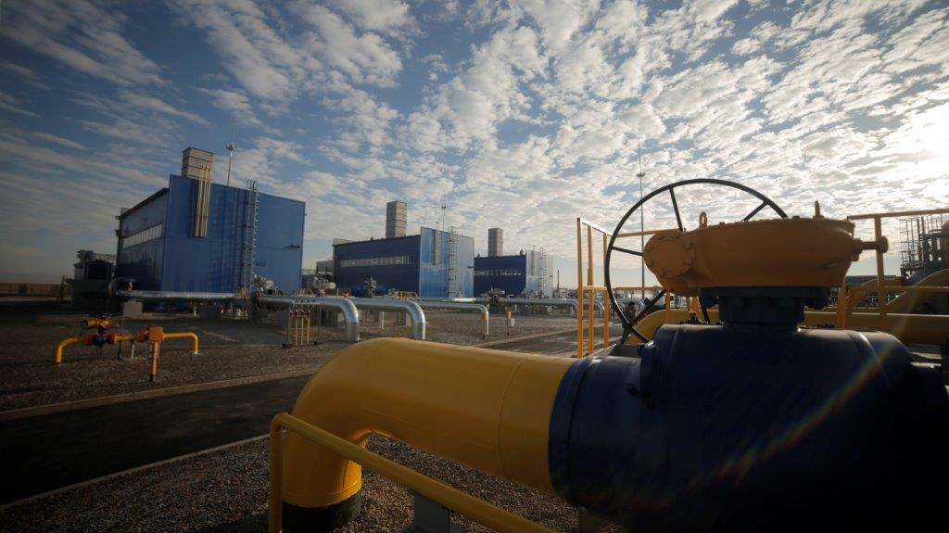

Gasification works were carried out as part of investment projects for distribution pipelines:
- The implementation of the project on expanding the gasification of settlements of Kostanay oblast has been completed. Seven settlements were gasified (Kachar village, Rudny town, Oktyabrskiy village, Lisakovsk village, Toguzak village of Karabalykskyi region, Antonovka, Alchanovka, Denisovskyi region, Auliyekol, Auliyekolsky region - supply gas was connected, Rudny - continued gasification). 238 km of gas pipelines were built for 2 years, the number of connected subscribers in the gasified settlements amounted to 1.2 thousand subscribers.
- Since 2012, a project has been implemented to modernize the gas distribution networks in Taraz. As of 01.01.2019 about 862 km of new gas pipelines were built and 29 thousand subscribers were reconnected to the new gas supply system.
- Since 2015, within the framework of the project on modernization, reconstruction and new construction of gas distribution networks of settlements in the Mangystau oblast, 1,322 km of gas pipelines have been built and modernized, about 1.7 thousand new subscribers have been connected.
- In 2018, a project was launched for further gasification of Almaty, modernization, reconstruction of gas distribution systems of Almaty. In 2018, 95 km of new gas pipelines were built in Almaty and 21.4 km were reconstructed.

Strategic goals of KazTransGas JSC Company Group

KazTransGas JSC and its subsidiaries and affiliates operating in the gas industry form a vertically integrated Company Group within KazMunaiGas National Company JSC.
In 2018, Samruk-Kazyna JSC developed a new Development Strategy for 2018-2028 with a mission to increase the national wealth of the Republic of Kazakhstan and long-term sustainability for future generations. In this regard, KMG updated and approved the Development Strategy until 2028 in October 2018 to ensure harmonization with the Development Strategy of the Fund for 2018-2028. The following strategic objectives have been identified in the field of gas transportation and marketing:

No. | Business initiative | Tasks
1 | Increase in gas reserves | - Reduction of the volume of raw gas re-injection into the reservoirs and associated petroleum gas flaring at large oil and gas fields in the RK;  - Construction of infrastructure for transportation and processing of associated petroleum gas to increase the volume of marketable gas
2 | Main transportation | - Ensuring the loading of existing capacities of main gas pipelines;  - Ensuring control over the composition and quality characteristics of gas entering the KTG main gas pipelines from gas producers located in the territory of the RK and gas coming from the territory of other states;  - Expanding throughput capacity of Beineu-Bozoi-Shymkent and Kazakhstan-China main gas pipelines (A and B lines);  - Increasing the operating rate of existing capacity
3 | Development of processing / gas chemistry | - Deep processing of gas to produce products with high added value;  - Creation of capacities for processing of associated petroleum gas into marketable gas;  - Expansion of the use of methane in compressed and liquefied form (CNG/LNG) as a motor fuel for the substitution of diesel fuel and motor gasoline, as well as gasification of remote settlements
4 | Gas marketing | Increasing gas exports to China to 10 billion m3 per year, starting from 2019

Financial and operational performance indicators of KazTransGas JSC Company Group
million cubic meters million cubic meters

billion cubic meters * km million cubic meters

KZT mln KZT mln

Main production and financial indicators in terms of subsidiaries and affiliates
The main activities of the Corporate Center of KazTransGas JSC are gas sales in the external and internal markets, as well as supervision of subsidiaries and affiliates engaged in gas sales, transportation and operation of gas distribution pipelines.

PRODUCTION INDICATORS
 | 2016 | 2017 | 2018 | in % by 2017
Sales of natural gas, million cubic meters | 16 086 | 17 742 | 22 916 | 129%
Domestic market | 11 763 | 12 793 | 13 999 | 109%
Export | 4 323 | 4 949 | 8 917 | 180%
(without deducting intragroup operations)

According to the central office of KazTransGas JSC in 2018, the sale of natural gas, without exception, intra-group operations amounted to 22,916 million m3, including for export - 8,917 million m3.
Gas supply for consumers of the domestic market is carried out by selling through KazTransGaz Aimak JSC and other gas distribution organizations from Kazakhstani subsoil users, as well as imported gas supplied within the framework of SWAP operations with Gazprom PJSC.

FINANCIAL INDICATORS, KZT MLN
 | 2016 | 2017 | 2018 | in % by 2017
Revenue from sales of products and services | 501 958 | 581 757 | 921 180 | 158%
Gross profit | 153 505 | 146 964 | 243 075 | 165%
Net profit | 81 395 | 74 781 | 155 975 | 209%

Intergas Central Asia JSC
The main activities of Intergas Central Asia JSC (ICA JSC) are transportation of natural gas through the system of main gas pipelines, gas storage services in underground storage facilities, operation and maintenance of gas pipelines and distribution networks.
Natural gas is transported through the territory of Turkestan, Zhambyl, Kostanay, West Kazakhstan, Almaty, Mangystau, Atyrau, Aktobe and Kyzylorda oblasts.
International transportation of natural gas is the main revenue component of ICA JSC business.

PRODUCTION INDICATORS
 | 2016 | 2017 | 2018 | in% by 2017
Gas transportation volumes, million cubic meters | 66 788 | 76 564 | 80 134 | 105%
Domestic market | 12 297 | 12 916 | 13 568 | 105%
Export | 13 251 | 16 710 | 18 873 | 113%
International transit | 41 240 | 46 938 | 47 693 | 102%

Compared to 2017, an increase in gas transportation volumes is observed due to an increase in the transit of Russian gas and exports.

Volumes of transportation of natural gas (million cubic meters)

UGSF, million m3 | 2016 | 2017 | 2018 | Deviations in 2018/2017, %
UGSF gas extraction | 1 274 | 1 752 | 1 699 | -3%
UGSF gas injection | 2 527 | 1 369 | 937 | -32%
Total active storage at the end of 2018 |  |  | 1 759
* The volume of injection in 2018 is below the level of 2017, due to the gas reserves in the Bozoi UGSF of gas KazRosGas LLP in the amount of 1.75 billion m3

Volumes of commodity transport works (billion cubic meters/km)

FINANCIAL INDICATORS, KZT MLN
 | 2016 | 2017 | 2018 | in % by 2017
Revenue from sales of products and services | 169 059 | 185 556 | 195 111 | 105%
Gross profit | 96 577 | 106 993 | 104 750 | 98%
Net profit | 57 196 | 64 586 | 59 529 | 92%

KazTransGas Aimak JSC
The main activity of KazTransGas Aimak JSC is to provide gas transportation services through main and distribution gas pipelines, marketing, purchase and sale of gas to consumers.
The priority task of KazTransGas Aimak JSC is to ensure trouble-free, uninterrupted and safe gas supply to consumers of all categories (population, municipal enterprises, and industrial enterprises) in the regions of presence of KazTransGas Aimak JSC.

PRODUCTION INDICATORS
 | 2016 | 2017 | 2018 | in % by 2017
Distribution gas transportation, million cubic meters | 9 217 | 9 597 | 9 848 | 103%
Main gas transportation, million cubic meters | 2 600 | 2 501 | 2 622 | 105%
Sales of natural gas, million cubic meters | 11 596 | 11 527 | 12 378 | 107%

Volumes of gas sales (million cubic meters)

FINANCIAL INDICATORS, KZT MLN
 | 2016 | 2017 | 2018 | in % by 2017
Revenue from sales of products and services | 195 324 | 227 415 | 242 042 | 106%
Gross profit | 20 967 | 25 170 | 23 421 | 93%
Net profit | 10 350 | 12 617 | 6 466 | 51%

Amangeldy Gas LLP
The main activities of Amangeldy Gas LLP are production of gas and gas condensate.

PRODUCTION INDICATORS
 | 2016 | 2017 | 2018 | in % by 2017
Gas production, million cubic meters | 327 | 344 | 349 | 101%
Gas condensate production, tons | 21 | 21 | 19 | 90%
In 2018, the execution of the production program in terms of the planned production volumes of gas and gas condensate was 101% and 90%, respectively.

FINANCIAL INDICATORS, KZT MLN
 | 2016 | 2017 | 2018 | in % by 2017
Revenue from sales of products and services | 7 244 | 12 767 | 13 010 | 102%
Gross profit | 3 993 | 9 302 | 8 707 | 94%
Net profit | 1 957 | 6 126 | 6 035 | 99%

Revenues from the sale of gas and gas condensate amounted to KZT 13,010 million.

KazTransGas Onimderi LLP
The main activity of KazTransGas Onimderi LLP is the provision of transportation services.

FINANCIAL INDICATORS, KZT MLN
 | 2016 | 2017 | 2018 | in % by 2017
Revenue from sales of products and services | 11 512 | 11 255 | 12 916 | 115%
Gross profit | 1 889 | 1 711 | 2 268 | 133%
Net profit | 231 | 271 | 473 | 175%

Gas engine infrastructure development
Action Plan on expanding use of natural gas as a motor fuel for 2019-2022, indicating targets for the volume of CNG sales, the number of buses and utility equipment for CNG and the construction of CNG stations, was approved by the Decree of the Government of the Republic of Kazakhstan dated 11.29.2018 No. 797.
According to the Minutes of the Meeting of the interdepartmental commission of the Security Council of the Republic of Kazakhstan on environmental safety issues dated December 12, 2018 No. 2, approved by the Assistant to the President - Secretary of the Security Council of the RK, G. Baizhanov, clause 4, the Ministries for Investment and Development, Energy, local executive authorities, KazMunayGas NC JSC, KazTransGas JSC were instructed to take measures to expand the use of natural gas as a motor fuel in the transport sector of the country's gasified regions and take control over the implementation of the Action Plan on expanding use of natural gas as a motor fuel for 2019-2022, approved by the Government of the Republic of Kazakhstan dated November 29, 2018 No. 797.
In 2018, the construction of new CNG stations was not carried out.
In 2018, 19,232,480.03 m3 of compressed natural gas (CNG) was sold from CNG stations in Almaty, Aktobe and Kostanay.
In 2019, it is planned to build new CNG stations as the relevant land plots are allocated and the consumer base is confirmed.

Investment activities
In accordance with the main strategic priorities and business areas, the long-term Investment Program of KazTransGas JSC is focused on the following tasks:
1. Implementation of the program for additional exploration and commissioning of new gas fields, the project of inert gases commercialization.
2. Ensuring a balanced, reliable and uninterrupted provision of gas transportation services to end users.
3. Modernization of the main gas pipelines system in order to increase their reliability, safety and efficient operation by optimizing the production and technological potential.
4. Expansion of the domestic gas supply market through gasification of settlements of the RK.
5. Development of transit and export potential of the Republic of Kazakhstan.
6. Expansion of the resource base.
Capital expenses to new investment projects for 2010-2018
(KZT million)

without projects of jointly-controlled organizations - AGP LLP, GBSh LLP, KazRosGas LLP
In 2018, the total amount of utilized investments in ongoing projects amounted to KZT 130.5 billion, which is KZT 48.3 billion more than in 2017. The growth of investments in the reporting period is associated with the start of construction-installation works as part of the implementation of new investment projects - construction of three compressor plants at BBSh MG and Gasification of Almaty and settlements of Almaty oblast.
In 2018, the following investment projects were successfully completed:
1. “Increasing the capacity of Kazakhstan-China MG (C line). Commissioning of the third line of the gas pipeline (C line) increased the capacity of Kazakhstan-China MG up to 55 billion m³ per year.
2. “Expanding gasification of settlements of Kostanay oblast” - 7 settlements (Kachar village of Rudnyi town, Oktyabrskyi village of Lisakovsk town, Toguzak village of Karabalykskyi district, Antonovka, Alchanovka in Denisovskyi region, Auliyekol in Auliyekolkyi region - supplying gas pipeline was provided, Rudnyi town - continued gasification) were gasified.
3. As part of the gasification of the northern and central regions of the Republic of Kazakhstan in 2018, the design-estimate documentation for construction of Saryarka MG was developed.

In 2018, the implementation of the following new investment projects began:
1. Construction of three compressor plants on Beineu-Bozoi-Shymkent MG.
2. Works on development of a feasibility study “Increasing the productivity of Kazakhstan-China MG (A and B lines) up to 40 billion m3 per year has begun.
3. Work has begun on the development of a feasibility study for expanding the capacity of Beineu-Bozoi-Shymkent MG up to 15 billion m3 per year.
4. Gasification of Almaty, modernization, reconstruction of gas distribution systems of Almaty. The project contributes to improvement of the ecological situation in the city, will allow connecting about 4.1 thousand new subscribers to the gas supply with an average annual consumption of 15.8 million m3 of gas.
It is planned to continue work within the framework of investment projects on modernization of gas distribution networks in Taraz, modernization, reconstruction and gasification of Mangystau oblast, expansion of the capacity of Bozoy UGS in Aktobe oblast.

PROJECTS AIMED AT EXPANSION OF THE RESOURCE BASE
Currently, in order to expand the resource base, implementation of the following investment projects is conducted:
- Development of the Amangeldy group of gas fields (Amangeldy Gas LLP);
- Production of coal bed methane of the Karaganda coal basin (geological exploration);
- Kansu project.

“Development of the Amangeldy Group of Gas Fields” Project
In accordance with the Gas Industry Development Program of the Republic of Kazakhstan for 2010-2014, in order to provide gas to consumers in the southern regions of the country and ensure the energy security of KazTransGas JSC on the basis of the Contract for combined exploration and production of hydrocarbons dated December 12, 2000, it continues to develop the Amangeldy group of gas deposits in Zhambyl oblast.
Duration of the contract is until 2031.
As a part of the project, commercial operation of the Amangeldy field and the development of other fields of the Amangeldy group are being carried out, including a complex of geological prospecting and seismic works, reserves calculation, development of pilot development projects, construction projects of producing wells and field construction facilities. Approved recoverable reserves of natural gas at the Amangeldy group fields amount to 18,747 million m3.
Since the beginning of 2008, the Amangeldy field has entered the stage of industrial development. Currently, 35 wells are in operation.
On November 27, 2014, the Zharkum field was put into pilot development, production is carried out at 6 wells.
On November 12, 2015, the exploration period was extended by 3 (three) years until December 12, 2018.
In 2018, the exploration period was extended by 3 (three) years until December 12, 2021.
On December 28, 2017, the Ministry of Energy of the Republic of Kazakhstan signed Addendum No. 12 to the contract for commissioning of the Airakty field into pilot production.
In 2014-2015 seismic investigation of CDPM 2D was carried out on the Sultankuduk structure in the volume of 257.1 linear kilometers, as a result of which the structure parameters and forecast resources were refined. The project “Addendum No. 2 to the project of prospecting works on the Sultankuduk structure (Barkhannaya-Sultankuduk site)” was developed, in 2016-2017 a well to a depth of 4,250 m was drilled and in order to clarify the prospects of the structure for the identification of industrial reserves of hydrocarbons.
In 2018, the construction of an assessment well No. 12 at the Anabay field was completed. Also, during the reporting year, reprocessing and reinterpretation of seismic investigation of CDPM 2D and 3D have been performed at the Barkhannaya-Sultankuduk sites and the Anabai field.
Since the beginning of industrial development at the Amangeldy field, 4.662 billion m3 of natural gas and 341.88 thousand tons of gas condensate have been produced, including 308.05 million m3 of natural gas and 18.34 thousand tons of gas condensate in 2018.
Since the beginning of pilot production at the Zharkum field, 59 million m3 of natural gas and 454.8 tons of gas condensate have been produced, including 8.311 million m3 of natural gas and 39.36 tons of gas condensate in 2018.
In 2018, 44.109 million m3 of natural gas and 691.97 tons of gas condensate was produced at the Airakty field.
As of January 01, 2018, 4.765 billion m3 of natural gas and 343.03 thousand tons of gas condensate were produced by Amangeldy Gas LLP.

The project «Extraction of coal bed methane of the Karaganda coal basin» (geological exploration works)
By the decision of the Management Board of KazMunayGas NC JSC, the project “Extraction of coal bed methane of the Karaganda coal basin” was included in the list of innovative projects of the Action Plan for the implementation of “The Strategy for innovative technological development of KazMunayGas NC JSC for 2014-2018.”
In September 2016, an updated Action Plan (Road Map) for the implementation of the order of the President for arranging exploration and production of coal bed methane (CBM) was approved by the Minister of Energy of the Republic of Kazakhstan. According to the specified Plan, KazTransGas JSC continues to carry out the 1st stage of the Project - geological exploration works within the framework of R&D in the contract area of ​​the subsoil user of Saryarka SEC JSC in the Sherubainur coal-bearing region of ​​the Karaganda coal basin (in accordance with the Agreement dated April 03, 2015).
The company regularly holds meetings with leading domestic scientists and subsoil users dealing with exploration and production of CBM, foreign companies with modern world technologies and experience in exploration and production of coal methane.
Geological exploration of CBM is a complex scientific-technical task, carried out within the framework of R&D and aimed at studying the gas content of the contract area and development of the most optimal production technologies for CBM. Within the framework of R&D, possible options are being tested for the application of modern foreign technologies / methods for well construction, development and intensification of CBM production rates taking into account international experience, involving qualified service contracting organizations, etc.
For the period of 2015-2017, exploration and pilot wells were drilled, gas inflow was obtained. Geophysical studies of wells, field and laboratory studies of core in the specialized laboratories of Corelab (USA), NCCBM (China), Geokrak (Poland) were carried out. According to the results of the core analysis, the characteristics of the coal in the Sherubainurinskyi site are similar to the largest US fields (Black Warrior - production of 1.5 billion m³/year).
The research development of test and production wells has been completed, the wells have been put into temporary conservation.
Baker Hughes Kazakhstan LLP has developed a feasibility study “Evaluation of the prospects for extraction and commercialization of CBM of Sherubaynurinskyi coal-bearing region of the Karaganda basin” (FS), according to the results of the FS, it was recommended to continue research.
In 2018, work was completed on the compilation of the report “Operational calculation of CBM R\reserves at the Sherubainurinskyi plot”, reserves were put on the state balance of the State Reserves Committee of the RK by category C₂ - 5.7 billion m³.
According to the recommendations of the FS and independent technical consultants, 3 wells were being constructed with a set of geophysical surveys.
In order to fully assess the prospects for CBM and to work out an effective technology for the extraction of industrial methane, taking into account the recommendations of experts from the KSTU and Baker Hughes project, KazTransGas JSC decided to continue research exploration on CBM.
In July 2018, taking into account the need to continue geological exploration, the decision of the KMG EC (Minutes of Meeting No. 13-18 dated 04.07.2018) approved additional funding for geological exploration at the expense of KTG's own funds in the amount of KZT 1,400 million.
Taking into account the geological conditions of the Karaganda coal basin, within the framework of R&D, high-tech structures with horizontal ends will be constructed in existing wells with multi-stage hydraulic fracturing in their horizontal sections.
For this work design documentation is currently being developed, the site has been prepared for field work.
According to the results of geological exploration - Phase 1 of the geological exploration project within the framework of R&D, a report on calculation of CBM reserves with the statement of coal methane reserves to the state balance of the Republic of Kazakhstan will be drawn up.
The decision on the further implementation of the Project will be made based on the results of geological exploration (Phase 1 of the geological exploration project within the framework of R&D).
In order to create favorable conditions for attracting investments and forming the optimal cost of CBM commercial gas for the population of the regions of the Republic of Kazakhstan, for the period of 2015-2017, KTG together with the authorized state bodies and organizations, in accordance with the Roadmap, conducted work on initiating the state support for CBM exploration and production:
- In 2016, the Law “On amendments and supplements to certain legislative acts of the RK on transition of the RK to a Green Economy” was signed, which approved measures of state support for CBM production in terms of obtaining current tax and investment preferences;
- in 2017, the Code of the Republic of Kazakhstan “On subsoil and subsoil use” was signed, where exploration and production of coal bed methane was regulated;
- proposals to the draft Decree of the Government of the Republic of Kazakhstan “On amendments and supplements to the Decree of the Government of the RK dated January 14, 2016 No. 13 “On certain issues of implementation of state support for investments”, providing for the right to include the implementation of investment projects for CBM production in the list of priority activities, were submitted to the Government of the RK.
For further development of CBM projects, negotiations are underway on joint cooperation with companies and investors.

«Kansu Project»
On October 21, 2015, the issue of alienating 100% of participation interest of KazMunayGas NC JSC in favor of KazTransGas JSC was approved by the decision of the Board of Directors of KazMunayGas NC JSC (Minutes of meeting No. 14/2015, clause 17).
On January 19, 2016, KMG-Kansu Operating LLP was reregistered at the Aktau Justice Department in connection with the change of the Sole Participant from KazMunayGas NC JSC to KazTransGas JSC.
On May 30, 2016, the Ministry of Energy of the Republic of Kazakhstan, KazMunayGas NC JSC and KMG-Kansu Operating LLP signed the Addendum No. 2 to the Contract regarding transfer of subsoil use rights under the Contract No. 3949-УВС dated 01.10.2013 for exploration of hydrocarbon raw materials in the Kansu site located in the Mangistau oblast.
On September 22, 2016 draft “Addendum No. 1 to the project for oil and gas exploration at the Kansu site” (hereinafter referred to as the Addendum) was reviewed and agreed at the meeting of the Central Commission for Mineral Prospecting and Exploitation of the Ministry of Economy of the RK and adopted for approval in the Ministry of Economy of the RK.
According to the approved Addendum, changes were made to the Work Program of the Contract for 2016-2019.
On October 1, 2016, the work on construction of a geological model of the Kansu field was completed. Three-dimensional geological models were constructed and the initial geological reserves were estimated for the Cretaceous and Jurassic deposits.
On October 31, 2016, the works on the project “Audit of the current state of environment at the Kansu site” were completed. The total area of ​​work is equal to the area of ​​the contract area of ​​the Kansu site and amounts to 4,374.64 square kilometers.
On December 2, 2016, a meeting of the Working Group of the Ministry of Economy of the RK (Minutes of Meeting No. 15 of the Working Group of the Ministry of Economy of the RK) regarding amendments and supplements to the Contract was held. Following the results of this meeting, the Competent Authority made a positive decision and on December 29, 2016, Addendum No. 3 to the Contract was signed.
In 2017, a technical project for construction of a search well R1 with a design depth of 3,800 meters was developed and approved by state authorities, including EIA at the Kansu field.
In 2018, due to lack of funding, no work on geological exploration was carried out.
Considering the absence of investors, according to the minutes of meeting No. 21 dated May 31, 2018 the KTG Investment Committee (hereinafter - EC) decided to preliminarily approve the withdrawal from the Kansu investment project.
In accordance with the minutes of the meeting of KMG EC No. 17-18 dated September 28, 2018, it was instructed to send conclusion to the IC KMG, following the results of the examination conducted by the Division “Exploration and Production of Hydrocarbons, Service Infrastructure of Mining Assets”, taking into account the opinion of TDB SRI, in order to adopt the final decisions till October 10, 2018.

EXPORT GAS PIPELINE PROJECTS
In order to expand export potential, work is underway to implement the following investment projects:
- “Increase of capacity of Kazakhstan-China MG (1st section)” (Asian Gas Pipeline LLP);
- “Construction of Beineu-Bozoi-Shymkent gas pipeline” (Beineu-Shymkent Gas Pipeline LLP);
- “Construction of a booster compressor plant on the TIP-02 jumper between BGR-TBA MG and Kazakhstan-China MG (ICA JSC);
- “Construction of three compressor plants at Beineu-Bozoi-Shymket MG (ICA JSC).

Project “Increase of capacity of Kazakhstan-China MG (1st section)”
On July 27, 2011, Minutes of meeting No. 2 “On amendments and supplements to the Agreement between the Governments of the Republic of Kazakhstan and the People’s Republic of China on cooperation in construction and operation of the Kazakhstan-China gas pipeline dated August 18, 2007” was signed, in accordance with which the Parties agreed to increase capacity of the first section of the Kazakhstan-China MG by 25 billion m3 per year, of which 20 billion m3 per year is intended for use by the Chinese side to transit of Turkmenistani and Uzbekistani gas to the PRC, and 5 billion m3 per year for the Kazakhstani side in order to meet the gas needs of the domestic market of Kazakhstan, as well as possible gas exports to the PRC.
The project involves the construction of a main gas pipeline with a length of 1,308 km and a capacity of up to 25 billion m3 per year.
Project implementation period: 2012-2018.
On September 26, 2011, KMG, KTG and TAPLine signed an Agreement on the basic principles of arranging the design, financing, construction and operation of the “C” line of the first section of the Kazakhstan-China gas pipeline.
As of the end of 2018, the following main works have been performed on the project:
- On July 9, 2015, the linear part of the gas pipeline was commissioned;
- On July 16, 2015, the compressor plant No. 6 was commissioned;
- On July 23, 2015, the compressor plant No. 2 was commissioned;
- On August 3, 2016, the compressor plant No. 4 was commissioned;
- On August 10, 2016 the compressor plant No. 8 was commissioned;
- On November 30, 2017, the compressor plant No. 1 was commissioned;
- On December 22, 2017 the compressor plant No. 3 was commissioned;
- On July 30, 2018, the compressor plant No. 5 was commissioned;
- On October 19, 2018, the compressor plant No. 7 was commissioned.
Thus, in 2018, the construction of all gas pipeline facilities was completed, and therefore the design capacity of up to 25 billion m3/year was achieved. The project is completed.
Since the start of the gas pipeline launch at the end of 2018, about 57 billion m3 have been transported (transit of Central Asian gas, export to the PRC and provision of the domestic market of the Republic of Kazakhstan).

Project “Construction of the Beineu-Bozoi-Shymkent gas pipeline”
The project goal is to ensure stable gas demand in the southern regions of the Republic of Kazakhstan, reduce dependence on imported gas and ensure the energy security of the Republic of Kazakhstan.
The gas pipeline route passes through the territory of Mangystau, Aktyubinsk, Kyzylorda and Turkestan oblasts and has the following main technical characteristics: Phase 1 - 2012-2019, throughput capacity of up to 6 billion m3 per year; Phase 2 - 2013-2019, throughput capacity of up to 10 billion m3 per year; Phase 3 - 2018-2019, the actual length of 1,450 km (in single-line version).
In order to implement the Project in the period 2010-2017 the following works were performed:
- the Governments of the Republic of Kazakhstan and the People’s Republic of China signed the Agreement on cooperation in construction and operation of the Kazakhstan-China gas pipeline (MPS) dated August 18, 2007;
- the Agreement was signed on the basic principles of construction and operation of the Kazakhstan-China gas pipeline (SOP) within the framework of the official visit of the PRC President Hu Jintao to Kazakhstan dated June 12, 2010;
- On January 18, 2011, for the purposes of the Project implementation, a joint Kazakhstan-Chinese project company, Beineu-Shymkent Gas Pipeline LLP, was established in the Republic of Kazakhstan;
- On December 2, 2013, the State Acceptance Commission Act was signed on commissioning of the linear part of the Bozoi-Shymkent site (311-1453 km), Bozoi GMS with a throughput capacity of up to 2.5 billion m3 of gas per year;
- On December 31, 2015, according to the order No. 278-ОД ДКРЕМиЗК of the RK No.2-ОД the tariff for transportation of commercial gas throughout main gas pipelines in the amount of KZT 18,071 per 1000 m3 excluding VAT was approved, effective from March 1, 2016;
- On December 30, 2016, the Acceptance Commission Act on commissioning of the linear part of the Beineu-Bozoi site (0-311km), with a throughput capacity of up to 5 billion m3 of gas per year, was signed;
- On November 7, 2017, the Acceptance Commission Act on commissioning of the Bozoi main compressor plant was signed, providing the throughput capacity of up to 6 billion m3 of gas per year;
- On November 29, 2017, the Acceptance Commission Act on commissioning of the Karaozek linear compressor plant was signed, and the throughput capacity was increased up to the designed - 10 billion m3 of gas per year;
- from the beginning of transportation until the end of 2018, 17 billion m3 were transported.
Work continues on the construction of Phase 2 railway road (0-311 km site), RPG and VP “Shornak”, “Karaozek”, “Aksuat” and “Saksaulsk”, “Beyneu” GMS, SCADA and Telecommunications systems.
The project update was approved with a view to expanding the capacity up to 15 billion m3/year (in the period 2018-2019), by expanding the existing Bozoi compressor plant (CP) and the Akbulak gas measuring station (GMS), as well as the construction of three additional new compressor plants.
At present, the design institutes - Kazakh Institute of Oil and Gas JSC (KIOG) and Chinese Engineering Corporation for Oil and Gas Pipelines (CECOGP) have completed the development of a feasibility study for increasing the productivity of the Beineu-Bozoi-Shymkent MG up to 15 billion m3/year. The development results are being endorsed by Beineu-Shymkent Gas Pipeline LLP.

The project “Construction of a booster compressor plant on the TIP-02 jumper between BGR-TBA MG and Kazakhstan-China MG”
In order to supply gas to the Kazakhstan-China gas pipeline for export to the PRC and uninterrupted gas supply to Almaty, the implementation of the project “Increasing the throughput capacity of BGR-TBA MG and the construction of a booster compressons plant at the TIP-02 jumper to supply gas to Kazakhstan-China MG is continued.
The project implementation period is 2016-2019.
As of the end of 2018, the following main works were performed on the project:
- On November 7, 2017, a selective overhaul of the linear part (LP) of the 2nd line of BGR-TBA MG was completed;
- On December 28, 2017, the Acceptance Commission Act on commissioning of the Akyr-Tobe booster compressor plant was signed, ensuring the possibility of supplying gas in the amount of up to 2 billion m3/year from BGR-TBA MG to Kazakhstan-China MG;
- The update project was approved with increasing the capacity of the booster compressor plant from 2 to 3.5 billion m3/g, by building a third gas compressor unit.

The project “Construction of three compressor plants on the Beineu-Bozoi-Shymkent MG
The project is being implemented as part of measures to increase the capacity of the Beineu-Bozoi-Shymkent gas pipeline from 10 billion m3 up to 15 billion m3 per year.
The project implementation period is 2018-2019.
In 2018, the construction of three compressor plants “Turkestan”, “Korkyt-Ata”, “Aral” was completed. In the period from November 2018 to January 2019 solemn launches were held, commissioning works are underway. Taking into account the completion of the construction of these compressor plants, the capacity of the Beineu-Bozoi-Shymkent gas pipeline reached up to 13 billion m3/g.

GASIFICATION PROJECTS OF REGIONS OF THE REPUBLIC OF KAZAKHSTAN
Project “Modernization of the gas distribution network in Taraz”
The project implementation period is 2011-2019.
The project provides for the replacement of low pressure steel gas pipelines with medium-pressure polyethylene in the low-rise sector, the replacement of dilapidated underground gas pipelines, the installation of individual cabinet gas control units with a SMART card directly at each low-rise building consumer, and the installation of block-type gas control units.
As a result of the modernization of the gas distribution system in Taraz, it is planned to increase the throughput capacity by 49 thousand m3/hour, from 101.5 thousand m3/hour to 150.5 thousand m3/hour, reduce technical and technological gas losses due to leakages through gas pipelines, reduce operating costs for capital repairs to 70% for next 40-50 years, extend the service life of the city’s gas distribution system for 50 years (warranty period for polyethylene gas pipelines), eliminate the possibility of unauthorized tie-ins and gas extraction.
As of January 01, 2019, the volume of investments utilized under the Project amounted to KZT 17.6 billion, excluding VAT, or 91% of the approved value. Since the beginning of the Project implementation, 29 thousand subscribers have been reconnected, 861.75 km of new gas pipelines have been built, 19,517 units, 27 gas distribution units, 1 gas control block uni have been installed.
Replacing the old aboveground steel gas pipeline with a more durable polyethylene in the underground version not only increased the reliability and safety of the networks, but also made it possible to preserve the unique architectural appearance of Taraz city.

Project «Modernization, reconstruction and new construction of gas distribution networks of settlements in Mangystau oblasts”
The investment project was initiated in 2015 within the framework of Memorandum of Understanding and Cooperation concluded on February 05, 2015 between the Akimat of Mangistau oblast, KazMunayGas NC JSC and KazTransGas JSC regarding long-term and mutually beneficial cooperation in the implementation of projects of construction, modernization and reconstruction of gas supply facilities in Mangystau oblast.
The project is aimed at upgrading and reconstruction, as well as the construction of gas networks in Mangystau oblast in order to improve reliability and the quality of services, eliminate gas shortages for consumers due to insufficient performance and poor technical condition of gas networks.
The project envisages the construction of new gas networks, high, medium and low pressure gas pipelines, high pressure feed gas pipelines with the installation of three AGDS in Zhanaozen, a gas lateral from the Okarem-Beineu MG to Shetpe cillage with the installation of AGDS, inter-settlement, inlet underground gas pipelines of high and medium pressure, as well as intra-settlement gas pipelines of low pressure.
As of January 01, 2019 the volume of investments utilized under the Project amounted to KZT 23.9 billion, excluding VAT, or 98% of the approved value.
As of the reporting date, totally 1,322.455 km of gas pipelines were built and upgraded, 6 sets of automatic gas distribution stations, 34 gas distribution unit, 41 gas distribution block units have been installed. 5 settlements (Batyr residential area in Munaylinskyi region, Zharma and Baskudyk villages in Mangystau region, Borankol village in Beineu region, 18 streets in Beineu village of Beineu region, 2 auls in Borankol village of Beineu region) were gasified, 1,000 new subscribers were connected.
In 2019, it is planned to complete the Project implementation.

Project “Expanding gasification of settlements of Kostanay oblast”
The investment project was initiated in 2016 in accordance with the tripartite memorandum of mutual cooperation between the Akimat of Kostanay oblast, KazMunayGas NC JSC and KazTransGas JSC, concluded on November 17, 2015.
The Project completed this year. The total investment cost is KZT 6.8 billion, excluding VAT. Within the Project, 237.889 km of new gas pipelines were built, 1 automatic gas distribution station, 11 gas control block stations, 4 gas distribution units were installed. Seven settlements were gasified (Kachar village in Rudny town, Oktyabrsky village in Lisakovsk town, Toguzak village in Karabalykskyi region, Antonovka, Alchanovka in Denisovskyi region, Auliyekol in Auliyekolsky region – gas feeding pipeline was connected, Rudnyi town - continued gasification).
The number of connected subscribers in gasified settlements amounted to 1.2 thousand subscribers, including 934 private houses, 250 apartments in large panel houses.

Project “Gasification of Almaty, modernization, reconstruction of gas distribution systems of Almaty”
The project was initiated in 2018 with a deadline till 2021, inclusive. The project envisages gasification of residential areas/areas with private houses in Almaty, which have not yet been connected to the gas supply system, as well as reconstruction of the existing gas distribution networks in Almaty. The project contributes to the improvement of the environmental situation in the city, will allow connecting about 4.1 thousand new subscribers to the gas supply system with an average annual consumption of 15.8 million m3 of gas.
In 2018, in Almaty 21.4 km gas pipelines and 10 cabinet gas control units were reconstructed. Gasification within the project and connection of new subscribers is planned from 2019.

Innovations

The Scientific and Technical Council (STC) operates as a part of the implementation of innovative development of KazTransGas JSC and in order to ensure the formation and implementation of a unified corporate and sectoral science and technology, innovation policy, the improvement of science and technology support activities for the KTG Company Group.
Proposals of an innovative, scientific and technical nature, programs of production and technical development of KTG structural units, as well as reports on developments of important technical and economic importance for the KTG Company Group are considered at the STC.
In 2018, 8 (eight) meetings of the KTG STC were organized.
14 issues were considered and approved, including 10 issues with the innovation component:
- Consideration of the rehabilitation technology of pipelines by the method of tight fitting of polyethylene sleeves as an effective method of major repairs and reconstruction
- Consideration of the composite-coupling technology of repair of main and field pipelines.
- Consideration of the technology of electrochemical corrosion protection of main gas pipelines by low current cathodic protection stations.
- Consideration of the Analytic integrated monitoring system for electrochemical protection with modular cathodic protection stations, as well as devices for maintaining protective potential and controlling currents.
5-6. Consideration of the use of high-quality ball valves, which do not require costs during operation, in new and current projects of the KTG Company Group (proposals from two different companies).
7-8. Consideration of the use of cable and wire products in new and current projects of the KTG Company Group (proposals from two different companies).
9. Consideration of the proposal on the possibility of using innovative insulation materials in new and current projects of the KTG Company Group.
10. Consideration of the anticorrosive protection technology of oil and gas facilities using modern coatings produced in Kazakhstan.
Following the meeting, the STC members took note the presentation materials, and also provided recommendations to the KTG subsidiaries and affiliates regarding the use of the most efficient technologies and products in ongoing and promising projects.

As a part of the STC, the production issues of the KTG Company Group were also considered:
1. Consideration of the issue on expanding the Akbulak GMS within the framework of the project on increasing the capacity of the Beineu-Bozoi-Shymkent main gas pipeline up to 15 billion m3/year.
2. Consideration of the gas transportation mode in Beineu-Bozoi-Shymkent MG, taking into account the connection of the Sary-Arka MG and with the planned gas extraction during the peak period during Phase I of construction of the Sary-Arka MG up to 622 thousand nm3/hour .
3. Consideration of the schedule for decommissioning of turbo-compressor shops, compressor plants and the linear part of gas pipelines along Central Asia-Center MG and Makat-Northern Caucasus MG.
4. Consideration of the issue on using ARAY-ALMA airborne diagnostic complex (light-engine aircraft CH 801HD EW “Arai” with a ДЛС Пергам-ALMA-G4 mini remote laser detector of methane emission) installed on board for detecting leaks at the GTN facilities.

According to the results of the STC activities, regarding innovations, in 2019 it is planned to conduct the pilot industrial testing of the Analytic integrated monitoring system for electrochemical protection with Analytic modular cathodic protection stations at the Akshabulak-Kyzylorda MG (41 km) with the aim of testing and subsequent introduction of new and current projects KazTransGas JSC Company Group. Deadline: 2-3 quarters of 2019.

Interested party transaction of KazTransGas JSC
In accordance with the Rules for concluding transactions between organizations belonging to Samruk-Kazyna JSC Group, in respect of which the Law of the Republic of Kazakhstan establishes special conditions, during the reporting period, the Management Board adopted 24 decisions on interested party transactions of KazTransGas JSC.

Asset structure

KazTransGas JSC
Amangeldy gas LLP 100%
Intergas Finance B.V.
100%
Intergas Central Asia JSC 100%
KazTransGas-Bishkek LLC 100%
KazTransGas Aimak LLP 100%
Asian Gas Pipeline LLP
50%
KazTransGas Onimderi LLP 100%
Auto Gas Almaty LLP 50%
Asian Gas Pipeline - Khorgos LLP 100 %
Beineu – Shymkent Gas Pipeline LLP 50%
KMG-Kansu Operating LLP 100%
KazRosGas LLP
50% (trust management)

Main directions of development
Company's plans for 2019
- Liquidation of KazTransGas Bishkek LLC, after return on investment;
- Continuation of geological exploration within the framework of the R&D project “Production of coal bed methane of the Karaganda coal basin”;
- Exit from the Kansu project;
- Completion of a feasibility study and design-estimate documentation for the project “Increasing the capacity of the Kazakhstan-China MG, A and B lines, up to 40 billion m3/year”;
- Continuation of the project on increasing the throughput capacity of the Beineu-Shymkent MG from 10 billion up to 15 billion m3/year (implementation in 2019–2020);
- Completion of the construction of the 2nd Sub-Phase complex (the 3rd GCU) of the Akyrtobe BCS;
- Completion of construction of the Korkyt ata compressor plant at Beineu-Bozoi-Shymkent MG;
- Completion of reconstruction of the Akbulak GMS at the Beineu-Bozoi-Shymkent MG;
- Completion of the project “Modernization of gas distribution networks in Taraz”;
- Completion of the project “Modernization, reconstruction and new construction of gas distribution networks of settlements in Mangystau oblast”;
- Completion of the reconstruction of collection stations No. 5 and No. 2 of the project “Reconstruction of the Bozoi UGSF”;
- Completion of the construction of 288 km of gas pipelines for the gasification of residential areas/sites with private houses in Almaty, continuation of the work on the reconstruction and modernization of existing distribution gas pipelines in Almaty.

Risk management

The activities of KTG and its subsidiaries and affiliates are subject to production and non-production risks. KTG is aware of the importance of risk management as one of the key components of the corporate governance system aimed at the timely identification, assessment and adoption of risk mitigation measures that may affect the achievement of the Group’s strategic and operational goals, as well as the value and reputation of the Group.
The purpose of KTG risk management is to ensure reasonable confidence in the strategic and operational sustainability of business.

The risk management program of KazTransGas JSC Company Group in 2018
As a part of the implementation of a vertical risk management process conducted by KazMunayGas NC JSC, risks identification, assessment and monitoring of KTG Company Group is carried out in the Automated Risk Management System (risk.kmg.kz) (hereinafter - ARMS).
During the period from February 1 to March 30, 2018, risk coordinators and risk managers of KTG and its subsidiaries were trained in basic requirements and work in ARMS; within May 17 – 18, 2018, risk managers and risk coordinators from jointly controlled organizations of KTG were trained in basic requirements and work in ARMS.
In KTG and its subsidiaries and affiliates, the structural unit and/or responsible person for risk management is subordinate to the First Head of the Company.
In the period from August 2 to October 1, 2018, interviews with key employees of all structural units of KTG and its subsidiaries and affiliates on risk management were conducted:
1) risks that may affect the goals achievement of KTG Company Group were identified;
2) the potential extent of damage in case of risk realization is determined.
The key risks of KTG and its subsidiaries and affiliates with the most significant impact on the Company's operations are below.
In KTG, 65 inherent risks have been identified, risk codes have been assigned in accordance with the Unified Risk Classifier of KTG and its subsidiaries and affiliates, risk owners have been identified and action plans have been developed to minimize risks.
For the KTG Company Group, 21 key risks were identified and displayed on the KTG Key Risk Map.
The default risk in terms of gas supply under the gas purchase and sale contract (export)
The risk is occurred due to several factors:
1. The increase in consumption in the domestic market;
2. Refusal to accept gas from the buyer;
3. Default by the supplier.
Legislative changes in business requirements.
The following factors affect the realization of this risk:
Restrictions in the implementation of KTGO business (production and commercial) activities. Transfer of more than 50% participation interest in a business to an outside organization. Lack of interholding cooperation. Uncertainties associated with dependence on a key partner - transition to market relations with the KTG Company Group and Samruk-Kazyna SWF JSC (Fund), participation in tenders for rental services of vehicles and special equipment conducted by KTG Company Group and the Fund on a common basis. Increased competition within the framework of the Fund Holding when participating in tenders of the Group and the Fund - the presence of large service motor transport companies of the Fund.
Uncertainties associated with dependence on a key partner (Gazprom PJSC)
The following factors affect the realization of this risk:
Refusal of Gazprom PJSC to purchase Central Asian gas. Reduction of gas export deliveries of Gazprom PJSC to Europe, including to Ukraine. The economic situation in Russia, the decline in domestic gas consumption in Russia. Non-fulfillment of contractual obligations by Gazprom PJSC or gas suppliers. Availability of the resource base of gas supplying countries to fulfill contractual obligations. The state of the global economy. Climatic conditions. Political and economic situation in gas supplying/consuming countries. The policy of Gazprom PJSC with gas consumers. Negative position of Gazprom PJSC regarding issues of increasing gas transit rates. Increased Russian gas production.
Tenge fluctuations against the US dollar
There is a possibility of currency losses associated with changes in the US dollar relative to the Tenge, interest rates, the state of the current trade balance, inflation rate, economic and political conditions.
Risk of non-return on investment of KazTransGaz Bishkek LLC
This risk is due to the unstable political situation in the Kyrgyz Republic (KazTransGaz Bishkek LLC).
The short supply of imported gas within the framework of exchange operations in the South of the Republic of Kazakhstan (gas shortage during the AWP)
The occurrence of risk is due to default by the supplier.
In order to systematize and unify risk management and internal control systems, KTG has developed a register of KTG risks, and key risks are applied to the Risk Map:

 |  | The level of inherent risk factors
 | 5 |  |  |  | 8
 | 4
Influence | 3
 | 2
 | 1 |  |  | 5 | 1,4,7 | 2,3,6
 |  | 1 | 2 | 3 | 4 | 5
 |  |  |  | Probability
No. | Name of the risk factor | Damage in KZT thousands
 |  | Inherent | Residual
1 | 278. Non-fulfillment by the counterparty banks of their obligations | 10 000 000 | 10 000 000
2 | 248. Failure to comply with tax legislation | 5 000 | 5 000
3 | 242. Failure of the company to comply with the requirements of the applicable law | 193 | 193
4 | 297. Decision-making by the authorized body in the field of tariff regulation | 16 369 740 | 0
5 | 312. Changes in political regimes in countries of strategic partners | 11 764 000 | 0
6 | 328. Amendments to tax legislation | 6 256 | 0
7 | 242. Failure of the company to comply with the requirements of the applicable law | 240 | 0
8 | 225. Failure to comply with financial/non-financial covenants | 300 000 000 | 0

Improving KazTransGas JSC risk culture
- The work of the Risk Committee has been strengthened; all significant events that may adversely affect the achievement of the goals of KTG and its subsidiaries and affiliates are collectively reviewed at meetings of the Risk Committees of KTG and the subsidiaries and affiliates.
- The work on arranging insurance protection of risks of KTG Company Group. Risk insurance training was organizaed.
- The event “Implementation of a vertical risk management process” included in KPI of the Managing Director for Gas Transportation and Storage of KazMunayGas NC JSC was implemented by 100%.
- A package of reports on financial risks has been formed - quarterly monitoring is conducted on:
- compliance with country risk limits;
- limits on obligations to counterparty banks;
- currency risks;
- interest breaks by currency.

Integrated Management System

The management in KazTransGas JSC and its subsidiaries and jointly controlled organizations, guided by strategic documents, determined strategic priorities aimed at providing strategic benefits and supporting the economy and social initiatives for the Republic of Kazakhstan.
The KTG Company Group strives to organize management in such a way that the quality level of activities meets the requirements and expectations of all stakeholders through increasing the company's income, increasing the staff material well-being, and promoting the growth of business opportunities of partners and suppliers. At the same time, the KTG Company Group strives to ensure safe working conditions for personnel and prevent negative environmental impacts.
The main principles of the KTG Company Group are quality improvement; prevention of negative environmental impact; ensuring the reduction of occupational risks.

The KTG Company Group uses the PDCA methodology in their activities. This methodology is the simplest algorithm of actions of a Head for managing a process and achieving its goals. The management cycle begins with planning.
Do
Execution of works planned.
Check (management, adjustment)
Taking measures to eliminate the causes of deviations from the planned result, changes in the planning and allocation of resources
Plann
Setting goals and processes necessary to achieve the goals, planning work to achieve the goals of the process and customer satisfaction, allocating necessary resources.

Act
Collecting information and monitoring the result based on key performance indicators (KPI), resulting in the process, identifying and analyzing deviations, determining the causes of deviations.
Сбор информации и контроль результата на основе ключевых показателей эффективности (KPI), получившегося в ходе выполнения процесса, выявление и анализ отклонений, установление причин отклонений.

Группа
компаний КТГ

Information on implemented measures in the field of management systems for KazTransGas JSC Company Group in 2018

Events held | Certificates
KazTransGas JSC
- Internal documents were updated.  - The procedure of internal audits in the field of IMS in the KTG Group was conducted in accordance with the Program for 2018.  - Training of employees responsible for the management system was conducted  - External assessment of the European excellence model at the level of “Recognized perfection” 3 stars was completed.  - The 2nd observational audit of IMS for compliance with the requirements of ISO 9001:2015, ISO 14001:2015, OHSAS 18001:2011 standards was completed. | 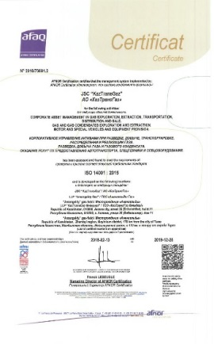  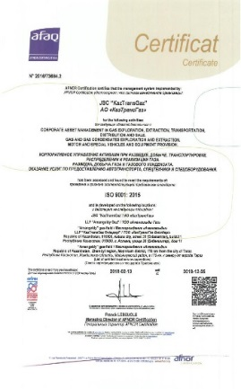  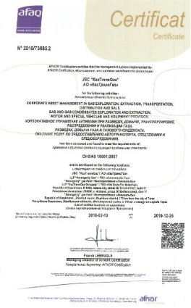
Intergas Central Asia JSC
- Internal audit of ISM organized by KazTransGas JSC was completed.  - External audit of IMS for compliance with the requirements of ISO 9001:2015, ISO 14001:2015, OHSAS 18001:2011, ISO 50001:2011, ISO 27001 was completed.  - External assessment of the European excellence model at the level of “Recognized perfection” 5 stars was completed.  - The grand prix of the competition for social responsibility of business “Paryz” in the nomination “For contribution to the environment” was received. | 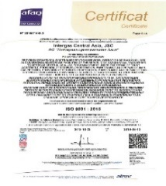  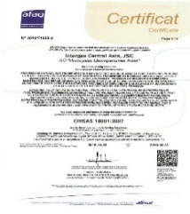  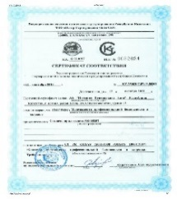  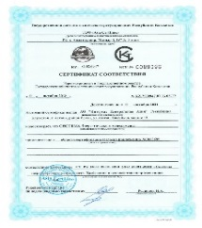  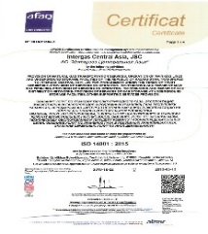
KazTransGas Aimak JSC
- Internal audit of ISM was conducted in the production branches.  - Internal audit of ISM organized by KazTransGas JSC was completed.  - Consulting and methodological services of IMS provemenet were provided in order to increase the effectiveness of the main business processes, as well as to develop and implement an innovation management system in accordance with the requirements of the international project Quality Innovation-2018 and its integration with the existing IMS.  - Observational audit of IMS for compliance with international standards ISO 9001:2015, ISO 14001:2015, OHSAS 18001:2007, ISO 50001:2011 was completed. | 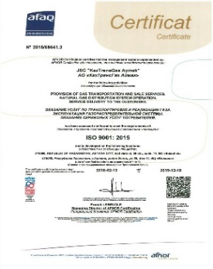  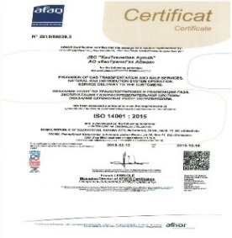  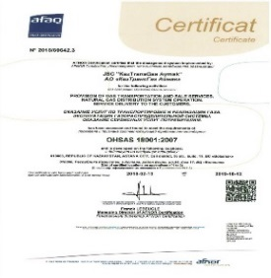  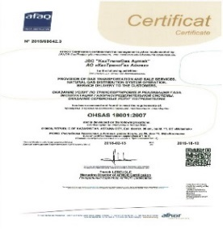
Amangeldy Gas LLP
- The 2nd observational audit of IMS for compliance with the requirements of ISO 9001:2015, ISO 14001:2015, OHSAS 18001:2011 standards was completed.  - External assessment of the European excellence model at the level of “Recognized perfection” 3 stars was completed.  - Permission to burn associated flare gas from the Zharkum field was obtained.  - As part of OHSAS 18001, pocket books “10 steps to recovery” were developed for health improvement.  - Consulting services for the development of IMS and business excellence model “EFQM-2013” in the Partnership were provided.  - Environmental aspects registry was revised. | 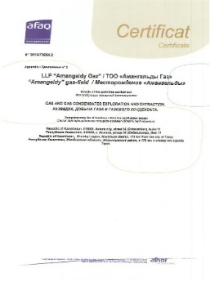  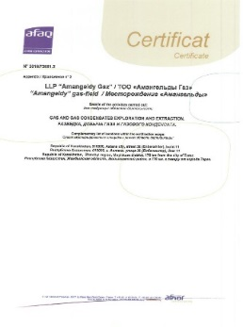  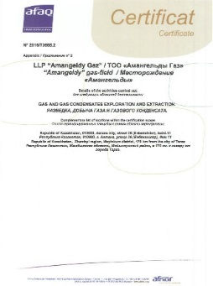
Beyneu-Shymkent Gas Pipeline LLP
- Internal regulatory documents of the Partnership were updated.  - Training of employees responsible for the management system was conducted.  - Planned assessment of compliance with applicable regulatory legal and technical documents requirements in the field of environmental and labor protection was conducted.  - Internal audit of IMS for compliance with the requirements of ISO 9001:2015, ISO 14001:2015, OHSAS 18001:2007 was completed.  - The 1st observational audit of IMS for compliance with the requirements of ISO 9001:2015, ISO 14001:2015, OHSAS 18001:2007 standards was completed.  - Internal audits of IMS, arranged by KazTransGas and Tapline, were completed.  - Evaluation of the effectiveness of corrective actions and actions to respond to risks. | 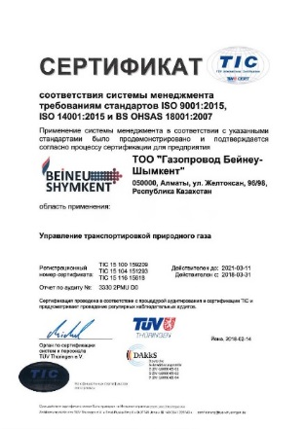
Asian Gas Pipeline LLP
- Internal regulatory documents of the Partnership were updated.  - Training of employees responsible for the management system was conducted.  - Internal audit of IMS for compliance with the requirements of ISO 9001:2015, ISO 14001:2015, OHSAS 18001:2007 was completed.  - Internal audits of IMS, arranged by KazTransGas and Tapline, were completed.  - IMS certification audit for compliance with new requirements of international standards ISO 9001:2015, ISO 14001:2015, OHSAS 18001:2007 was completed. | 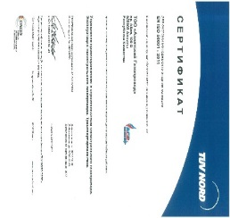  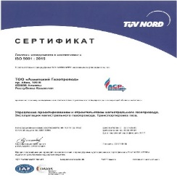  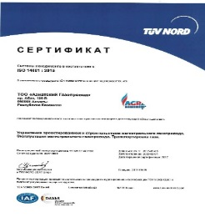  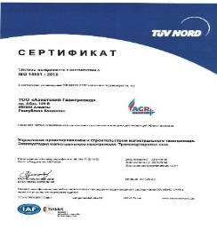
KazTransGas Onimderi LLP
- The 2nd observational audit of IMS for compliance with the requirements of ISO 9001:2015, ISO 14001:2015, OHSAS 18001:2011 standards was completed.  - External assessment of the European excellence model at the level of “Recognized perfection” 3 stars was completed. | 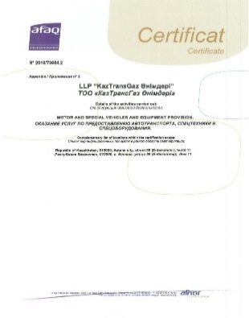  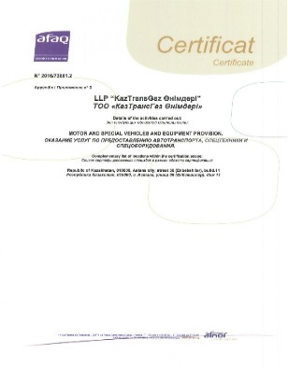  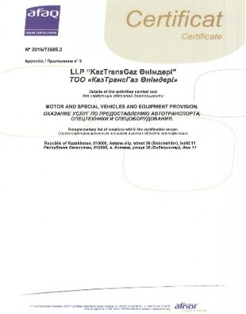
KazRosGas LLP
- In connection with the introduction of business processes for risk management, amendments and supplements were made to internal documents.  - The second observational audit of IMS for compliance with the requirements of international standards ISO 9001:2015 was completed. | 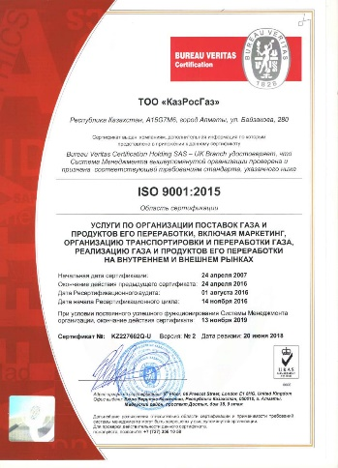

On December 11, 2018, a subsidiary of the KTG Group,  Intergas Central Asia JSC, won the grand prix in the competition for the social responsibility of business “Paryz” in the nomination “For contribution to the environment.” | 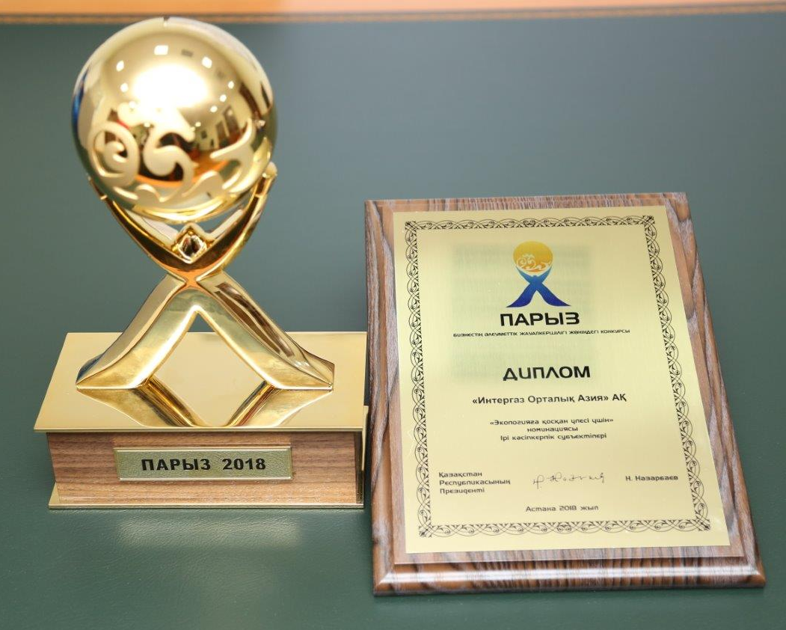

Information about the availability of certificates in the field of management systems for KTG Company Group

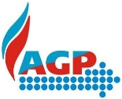
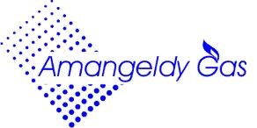
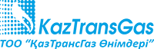
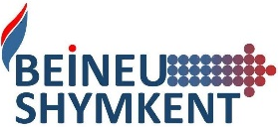
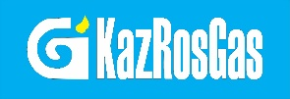

Health, Safety and Environmental Policy

Use of energy resources and energy saving
One of the tasks of KazTransGas JSC is to monitor the activities of subsidiaries and affiliates for compliance with the requirements of Law of the Republic of Kazakhstan “On Energy Saving and Improving Energy Efficiency”.
KazTransGas JSC pursues a policy of energy saving and energy efficiency increase. The areas of activities in the field of improving the energy efficiency of the KTG group of companies for transportation, distribution, production and underground storage of gas are defined in the ASs’ activities on energy saving and energy efficiency.
The main objectives of energy saving policy are:
- Realization of energy saving potential and improvement of energy saving management;
- Appliance of innovative technologies and equipment to reduce the anthropogenic impact on the environment.
The main energy saving measures for the KTG group of companies for 2019:
- Optimization of loading compressor stations CS;
- Optimization of power plant loading at CS;
- Optimization of operating modes of electrically driven gas pumping units, power supply circuits according to the operating mode of compressor stations, including shutdown of power transformers of backup power supply of turbo-compressor shops;
- Installation (instead of obsolete) of new generation cathode stations;
- Reconstruction of the boiler house UGS Akyrtobe, CS “Redut” with the replacement of water boilers for energy efficient;
- Use of energy efficient Wilo net pumps with electric motors of lower power during the reconstruction of boiler houses;
- Installation of solar panels with a total power of 10 kW to power the lighting network of the industrial site of Amangeldy Gas LLP.
Improvement of energy efficiency indicators is conditioned by use of optimal gas transportation modes and energy saving measures.
The volume of consumption of fuel and energy resources (FER) in KTG group of companies for 2018 amounted to: 1 758 627,0 tons of fuel equivalent (tons of equivalent fuel) (119,7 million kWh, 1 474 175,3 thousand cubic meters) compared to 2017 – 1 303 910,9 tons. (124,4 million kWh, 942 392,9 thousand cubic meters), increased by 34.8%. The increase in energy consumption in 2018 is due to the growth in gas transportation volumes in Kazakhstan-China GP and Beineu-Bozoi-Shymkent GP.
The total amount of generated (produced) renewable energy by source for 2018 was:
1. Generation of geothermal (heat) energy by heat pumps – 678,53 Gcal.
2. Electric power generation by solar panels – 103572 kW*h.
3. Generation of electrical energy by thermal power generators (TPG - Rankine cycle) – 240900 kW*h.
The specific energy costs for transportation of natural gas, an indicator of the energy efficiency of gas transportation for 2018, amounted to 0,0203 tons of fuel equivalent/thous.tenge compared to the same period of 2017 (0,0105 equivalent/thous.tenge) increased by 94%. The increase in the level of energy consumption is associated with an increase in the volume of gas transportation in Kazakhstan-China GP and Beineu-Bozoi-Shymkent GP.
Energy saving potential in KTG group of companies for 2016-2020 is 67 588,12 tons of equivalent fuel.
Saving of fuel and energy resources (FER) in KTG group of companies amounted to:
2016 – 9363,94 tons of equivalent fuel (4993 thousand kW*h, 7478,346 thousand cubic meters);
2017 – 9305,46 tons of equivalent fuel (3393,2 thousand kW*h, 6500,5 thousand cubic meters);
2018 – 12552,32 tons of equivalent fuel (4946 thousand kW*h, 9620,8 thousand cubic meters).
The main energy-saving measures are aimed at reducing the consumption of natural gas and electricity.
As part of the support of the “Digital Kazakhstan” program, which is initiated by the Head of State, Intergas Central Asia JSC in 2019 will conduct an industrial test of the Analytic system with modular cathodic protection stations at the Akshabulak-Kyzylorda GP (41 km) with approbation and subsequent implementation on new and current projects of KTG group of companies.
Renewable energy sources that have been introduced into ASs in previous years work effectively: gas pumping units (GPU) with a low-emission DLE combustion system; compensating devices designed to compensate for reactive power (reactive parameters of electrical networks); geothermal heat pumps of the “Waterkotte” type; monocrystalline solar panels (batteries); thermoelectric generators (Closed cycle vapor turbogenerator) and block complete power plants (Capstone), operating in standalone mode; integrated Automatic system for commercial accounting of power consumption (ASCAPS), energy-saving lighting lamps.
Taking into account the projected increase in the cost of energy (natural gas, electricity), as well as the growth of their consumption, a common task for all subsidiaries and affiliates of KazTransGas JSC is to reduce the cost of fuel and energy resources through the implementation of economically viable energy saving measures and energy efficiency.
Development and improvement of regulatory documents in the field of renewable energy should create a support mechanism that will guarantee investors return on their investments and, as a result, attract potential investors to implement and develop projects in the field of renewable energy on the territory of the Republic of Kazakhstan.

Health, Safety and Environmental Policy
Work to ensure HSSE at the production facilities of KTG group of companies is carried out in accordance with the applicable laws, regulations and regulatory and technical acts of the Republic of Kazakhstan, the “Uniform Occupational Safety Management System” of KazMunayGas JSC and (UOSMS) of subsidiaries and affiliates of KTG.
An extended meeting was held on HSSE in KTG group of companies in Astana. Reports of Heads of departments/services of labor protection, industrial safety and environmental protection of the subsidiaries and affiliates on the implemented HSSE work were presented. The reports were accepted positively, and further tasks to improve the above work were prescribed in Minutes.
The following mobile applications have been implemented for KTG group of companies:
- “8 Golden Rules”;
- “ABC Book”;
- “10 Steps to Recovery”.
These applications are developed in state/Russian languages ​​and are available for installation with IOS and Android devices, are also fully integrated into the activities of KTG.
The Code of Workers in the field of safety and security works “Golden Rules” for the KTG group of companies are executed.
With the participation of KTG, the “Regulations for Safe Operation of Land Vehicles”, approved by “KazMunayGas” NC JSC, were introduced in KazTransGas-Onimderi LLP.
In order to ensure safety, a seatbelt simulator was purchased. The seatbelt simulator plays a traffic collision, in which participants experience a collision force.

Labor Protection
100% transparency of reporting on labor and environmental protection has been achieved, which is confirmed by the findings of KazMunayGas NC JSC on the results of on-site (selective) inspections of production facilities of KTG group of companies. Transparent reporting for KTG group of companies is ensured by the timely submission of reliable data on all types of incidents in the KISUD program.
In accordance with the requirements of legislation in the field of labor protection, the measures have been organized and carried out on multilevel control, training and testing of knowledge, certification of facilities for working conditions, creation of sanitary and hygienic working conditions, provision of working clothes, accident insurance, medical and pre-shift certification.
On October 9, 2018, when carrying out repair works for replacement of defective pipes in section 647-694 km along the Luping GP CAC, located between Zhylyoi and Makat districts of Atyrau region, near EPE 783 support at 651 km at 15:01 Mr. Ye.K. Sydykov, driving a KrAZ State No “365AL06” truck crane and making a left turn maneuver, was unable to cope with the steering and allowed the truck crane to roll over to the left, resulting death.
In accordance with Chapter 20 (Article 186-189) of the Labor Code of the Republic of Kazakhstan, investigations were conducted with the drawing up of Acts and the development of measures to prevent accidents. All activities are completed.

Fire Safety
During the reporting period, fire prevention measures were carried out at the facilities of KTG group of companies: fireproof treatment, repair, inspection and reloading of fire extinguishers, training and instructing personnel on fire safety measures, installation of automatic fire extinguishing and alarm systems, maintenance of fire-fighting automation systems, installation and repair of fire-fighting water supply.
Contracts for the protection of objects from fires are concluded.

Industrial Safety
During the reporting period, KTG group of companies carried out such activities as: diagnostics of pipelines, replacement of defective sections of pipelines, replacement of cranes, replacement of pipe insulation, training and testing of personnel knowledge, declaration of production facilities, production control.
Contracts have been concluded to ensure anti-fountain security and to protect facilities from unlawful actions.

Environmental Safety
As a result of the conducted monitoring of the environment for 2018, there were no exceedances of the issued permits for emissions into the environment. The strategy of environmental protection plans contains nine main sections, which provide for the protection of the air basin, the rational use of water and land resources, flora and fauna, the management of industrial and consumer waste, the introduction of management systems and the best available technologies, research and design and survey work, radiation biological and chemical safety; and environmental education and outreach. For example, the company’s modernization of gas distribution systems leads to a significant reduction in pollutant emissions and greenhouse gases. Continuous monitoring of air and wastewater allows to control the condition of environment.
On December 11, 2018 in Astana, the ceremony of awarding the winners of the competition for social responsibility of business “Paryz” took place. Intergas Central Asia JSC took the honorable first place in nomination “For Contribution to the Environment”.
The work on an annual inventory of sources of greenhouse gas emissions and the submission of greenhouse gas passports to an authorized body for further registration in the state cadaster is continued. Also we participated in the meetings held by the Ministry of Energy of the Republic of Kazakhstan on new standards for greenhouse gas emissions on the transition of the Republic of Kazakhstan to the “Green Economics”.
At the suggestion of the Ministry of Energy of the Republic of Kazakhstan, KazEnergy, KTG, a number of laws and regulations of the Republic of Kazakhstan concerning the field of environmental safety were considered.

Social Responsibility
HR Policy
KTG, being aware of its social responsibility of business, is making efforts to promote social progress and increase the welfare of society, sustainable development and well-being of the population of the regions, and improve the well-being of its employees. Taking care of each employee, the priority of solving social issues is the basis of KTG policy.
Against major changes, there is a need to introduce innovations in a timely manner, ensuring the organization’s compliance with the external environment. At the same time, the personnel policy is being finalized as it is implemented in response to the new requirements of a constantly changing external environment, except for that part of the personnel policy, that affects the key interests of workers (for example, employment policy, remuneration), which must be predictable and stable.
Personnel policy is designed to combine existing approaches, established methods and tools of personnel management, taking into account the best experience in the field of work with personnel, thus allowing to form a unified approach and develop a corporate system of values ​​of KTG in the field of personnel management.
The basis for the developed HR policy is the following basic principles:
- Transparency – openness at all stages of the human resource management process;
- Complexity – coverage of all areas of human resource management;
- Sistemacity – consideration of all the constituent elements of the policy in the relationship;
- Sufficiency – use of modern scientific developments in the field of personnel management, which could provide the maximum economic and social effect;
- Efficiency – cost of measures in the field of personnel management should pay off by results of production activities.

Social protection of employees of the group of companies
KTG group of companies pays great attention to the growth of social payments, which are aimed at creating a healthy working climate in groups, which allows employees successfully perform their basic functions. KTG defines a unified corporate policy in the field of social support for employees and pays significant attention to social benefits, a significant share of which is material assistance and a package of social services.
KTG offers its employees a package of social services, including medical insurance, compensation and material assistance, including treatment and rehabilitation of workers during their leave, etc. On the basis of collective agreements and the Rules for the provision of social support in 2018, the following basic types of material assistance were paid to employees of KTG group of companies:
- financial assistance to leave for rehabilitation - 3 414 401 thousand tenge;
- at childbirth - 134 521 thousand tenge;
- in connection with the death of family members of the employee – 77 812 thousand tenge;
- one-time payment in connection with the death of the employee – 7 767 thousand tenge;
- social benefits for pregnancy and childbirth, adopting and adopting newborns - 37 060 thousand tenge;
- other payments (upon entry into marriage, upon retirement, for anniversaries, etc.) - 77,823 thousand tenge.
In order to strengthen the corporate spirit, promotion of physical culture and sports, as an important factor in the formation of a healthy lifestyle among employees, a Spartakiad was held among the employees of KazMunayGas NC JSC group of companies. Employees of the group of companies KazTransGas JSC took part in Spartakiad.
In 2018, 91 858 thousand tenge was spent on organizing children’s events and organizing recreation for children of socially vulnerable workers aged from 7 to 14.
The total amount of social payments for KTG group of companies (including social payments by the employer) in 2018 amounted to 3 841 242 thousand tenge.

Quality of working conditions, the lives of workers and their families
To ensure the quality of the working and living conditions of workers and their families, the budgets of KTG group of companies annually allocate funds for voluntary medical insurance, including a wide range of medical services in the best clinics of Kazakhstan. At the same time, the program of medical care for the employee, along with the provision of the entire range of medical services, provides for services on the same terms and conditions of his family (parents of the employee, spouse and children). In addition, the range of services of insurance company provides patronage of physiological pregnancy.
Thus, in 2018, at the expense of KTG group of companies, medical insurance of employees was provided in the total amount of 989 million tenge, including insurance of employees of KazTransGas JSC for 43 million tenge.
As it is known, the work of most gas industry workers is associated with gas pipelines and is characterized, on the one hand, by harsh climatic conditions (drinking water, dust storms, etc.), and on the other hand by the fact that transit gas pipelines are often in ecologically unfavorable regions of the country.
In accordance with the legislation of the Republic of Kazakhstan “On Social Protection of Citizens Affected by the Environmental Disaster in Aral Sea Region”, the residents of the Aral Sea region receive an environmental ratio in the amount of 20% to 50% to the basic salary, as well as additional leave in the amount of 6 to 12 days.
Work to prevent diseases among workers, as well as their treatment and rehabilitation during the holiday period is also carried out.
KTG pays great attention to the growth of social payments, a significant proportion of which is social benefits and guarantees. First of all, they are aimed at creating a healthy working microclimate in groups on the basis of social partnership, which allows employees to successfully perform their basic functions.
Also in KTG, there are public associations of workers’ trade unions, within the framework of which collective bargaining agreements between employees and employers have been concluded, which provide for social guarantees, payments, compensations and benefits to employees, significantly exceeding those established by labor legislation, for example, such as:
- payments in connection with the entry into first marriage, birth of a child, for burial in connection with the death of relatives, etc.;
- additional paid leave in connection with the above cases;
- children’s camps for children of company employees;
- etc.

Preparation, training and professional development of employees of the group of companies
Taking into account the fact that the movement of personnel should be as predictable as possible, as well as planned and consistent with the general concept of the company's development, a general integrated approach is needed for all stakeholders: students, representatives of educational organizations and the Company to enhance its human resources. Therefore, in order to systematically fill the resulting vacancies, as well as to form a group of young professionals who have the ability to operational management activities that meet the requirements of a position in one direction or another, the Rules for the Training of Young Professionals have been developed and approved in separate ASs of KTG. This internal document describes the procedure for determining the need for training young specialists, the recruitment of candidates, the procedure for sending them to study at educational institutions of the Republic of Kazakhstan and in foreign countries. At present, the composition of the commission for the development of external personnel potential has been approved, and correspondence is maintained with higher educational institutions on this issue. In addition, the training of specialists is carried out in the group of KazTransGas JSC in accordance with the calendar plans of education and training of specialists, including foreign training. Training of specialists with higher education for organizations of KTG group of companies is planned on the basis of the best technical universities.
KTG employees are taking part in advanced training courses, seminars, internships and trainings both on the basis of the Private Institution “Samruk-Kazyna Corporate University”, Astana, in other training centers of the Republic of Kazakhstan, as well as abroad.
KTG has the following programs aimed at staff development, such as “Training and Professional Development”, as well as the program “Young Specialist”.
The personnel reserve of KTG group of companies is formed.
“Training and Professional Development” is a permanent program for the development of company personnel.
KTG has a staff development program aimed at training and continuing education. Each year, KTG budget provides funds for training and staff development. In KTG in accordance with the Rules for the Technical Operation of Main Gas Pipelines the technical objects of main gas pipelines must be operated by specially trained personnel. Personnel servicing objects of increased danger must undergo training (retraining) on ​​courses specially created by enterprises according to programs agreed with local bodies of state technical inspectorate.
In 2018, the KTG group of companies trained 7,647 employees for a total amount of 720,991 thousand tenge, employees undergo training and improve their qualifications on the basis of training organizations and training centers of the Republic of Kazakhstan. Vocational training and development of working personnel is one of the long-term and priority directions of the personnel policy of KTG, since professional level of workers is the most important factor in increasing the efficiency of safe production, increasing productivity and improving the quality of work.
Also, at KTG, children of the Company’s employees are trained in higher educational institutions of Kazakhstan and abroad at the expense of AS and KTG, who, after completing the training, will return to work in gas transportation industry.
In addition, in 2018, within the framework of the top management training program for the KTG group of companies, 15 Managers received diplomas on successful completion of the course: “Integrated program for development of TOP-Management of AS of KazMunayGas NC JSC at the Institute of Engineering and Information Technology KBTU”.

Sponsorship and Сharity
In 2016, due to the entry into force of the “Policy of Providing Sponsorship in KazMunayGas JSC NC, the provision of sponsorship was terminated.

Corporate Governance
KTG, being the Gas Operator of Kazakhstan, confirms its commitment to development and achievement of goals in accordance with the Development Strategy of KazMunayGas NC JSC until 2028: value creation and strengthening financial sustainability, corporate governance and sustainable development.
One of the strategic directions of KTG activities is to increase the efficiency of corporate governance.
KTG assumes that effective corporate governance is a fundamental condition for the sustainable growth of the Company’s capitalization, reducing the likelihood of corporate conflicts, increasing the Company’s attractiveness for investors, as well as a positive impact on the image.
The goal of corporate governance is to ensure the effective operation of KTG, increase the value of its share capital, ensure the protection of investors’ rights and the realization of the interests of the Sole Shareholder.
The Company, understanding the importance of corporate governance, pays great attention to the implementation of corporate governance principles. In 2015, the new version of the Corporate Governance Code was approved. The Corporate Governance Code of the Company was developed in accordance with the Corporate Governance Code of Samruk-Kazyna NWF, approved by the Government of the Republic of Kazakhstan by Decision No 239 dated April 15, 2015.
The Company seeks to establish a balance of interests of Sole Shareholder, Company’s management and interested persona, while the corporate governance system of KTG, as a holding company, includes the interaction of several levels of corporate ladder: general meeting of shareholders, the Board of Directors, the executive body of KTG and similar governing bodies of AS.
As part of the preparatory measures to create an effective corporate governance system, changes were made to the organizational structure of holding: KTG, as a national operator in the field of gas and gas supply, is a corporate center designed to limit the possibility of diluting the ownership structure, minimize the costs of information disclosure, simplify the procedure for management decision making.
A reasonable distribution of functions between the general meeting of shareholders, the Board of Directors and the executive bodies, both KTG and its AS, is enshrined in charters and does not interfere with the management of the AS to carry out the current management.
In order to achieve the goals and objectives of corporate governance of KTG in relation to AS, within the framework of business transformation, their organizational structures are redesigned, which involves the redistribution and regulation of the powers and responsibilities of officials within the framework of corporate management, optimization of corporate business processes interaction, in addition to the principles characteristic of any joint-stock company.
KTG introduces integrated standards of corporate governance (observance of the rights of shareholders and stakeholders, informational transparency, the existence of an effective Board of Directors, a clear division of powers and responsibilities between the company’s governing bodies, a transparent ownership structure, an effective internal control system). It is possible to single out in KTG the principle of pursuing integrated corporate governance standards, ensuring the implementation of common strategic goals for KTG and its AS.
The interests of KTG in the activities of subsidiaries and affiliates are implemented in the development and implementation of the policy (or program) of corporate governance, which includes several areas, such as:
- planning and monitoring the financial results of the activities of AS, including determining the direction and control of the AS profits distribution;
- control of financial and economic activities of AS, including transactions with assets of AS;
- continuous improvement of the efficiency of internal processes of AS in business management;
- ensuring investment attractiveness and growth of capitalization of AS;
- formation and implementation of personnel policy of AS.
The Sole shareholder defines the corporate governance model, which includes such participants as “active” shareholder, Board of Directors, Management Board and centralized internal audit service.

Interaction with Shareholder
The Sole shareholder of KTG is KMG. KMG plays an active role in formation and development of corporate governance in KTG. KMG contributes to development of corporate governance in KTG through:
- introduction of the Corporate Governance Code in 2007 and participation in development of a new Corporate Governance Code, approved by the Government of the Republic of Kazakhstan in April 2015;
- provision of methodological support in implementation of corporate governance standards, including diagnostics of the level of corporate governance.

Interaction with affiliated subsidiaries
Interaction with AS is carried out within the framework of approved corporate procedures through the relevant bodies of KTG and AS.
The main objectives of the interaction of KTG with AS are:
- ensuring the stable financial development, profitability, increasing the investment attractiveness of KTG and its AS;
- ensuring the protection of rights and legally protected interests of shareholders and shareholders of AS;
- harmonization of relations between shareholders, officials and employees of KTG and AS, by taking systematic measures to prevent conflicts between them and within these groups;
- development and implementation of coordinated and efficient investment policy of KTG and its AS.

Corporate governance mechanisms in KTG group of companies
- building a vertical management system for AS;
- introduction of uniform corporate standards in AS;
- nomination of own representatives to the governing bodies of AS;
- ensuring the joint voting of representatives on issues discussed on the basis of recommendations of the Company’s representatives on the Boards of Directors of AS on agenda items;
- organization of control over the activities of AS through representatives in management bodies, conducting audits of financial and economic activities, election of an auditor, etc.

Corporate Governance Bodies
The Сorporate governance bodies of KTG are:
1) Sole Shareholder - the highest authority;
2) Board of Directors - the governing body that carries overall management of the Company’s activities and determines the priority areas of its activities. The Board of Directors consists of five members, two of whom are independent directors.
3) Management Board – collegial executive body that manages the current activities of the Company in order to fulfill the objectives and implement the strategy of the Company.
As of December 31, 2018, KTG Management Board consisted of seven persons.

Board of Directors Structure
As of January 1, 2018, the Board of Directors consisted of five members, who were:
Full name of Director | Position in KTG
Kairat Sharipbayev  Ardak Mukushov | Chairman of the Board of Directors  Member of the Board of Directors
Rustam Suleimanov | Member of the Board of Directors
Airat Nurgaziyev  Serik Zhamanbalin | Independent Director  Independent Director

By the decision of Sole Shareholder (Minutes of KMG Board of Directors No 1/2017 dated January 26, 2017), KTG Board of Directors was re-elected for 3 years from February 20, 2017.
During 2018, the composition of the Board of Directors of KTG did not change.
The composition of the Board of Directors on December 31, 2018:
Full name of Director | Position in KTG
Kairat Sharipbayev  Ardak Mukushov | Chairman of the Board of Directors  Member of the Board of Directors
Rustam Suleimanov | Member of the Board of Directors
Airat Nurgaziyev  Serik Zhamanbalin | Independent Director  Independent Director

In accordance with the Corporate Governance Code of KTG, the Board of Directors established the fact of independence of Directors Airat Nurgaziyev and Serik Zhamanbalina:
- comply with independence criteria applicable to them by the legislation of the Republic of Kazakhstan.
- have relevant work experience, knowledge, qualifications, positive achievements and impeccable reputation in the business environment and gas industry of Kazakhstan, necessary to perform their duties and organize effective work of the entire Board of Directors in the interests of Sole Shareholder and KTG;
- comply with requirements of the Regulation on the Board of Directors of KazTransGas JSC, which does not allow relations or circumstances that could influence the recognition of a member of the Board of Directors as independent.

Attendance by members of the Board of Directors of the Board of Directors meetings
Full name | Position | Attendance | Attendance in % | Note
Kairat Sharipbayev | Chairman of the Board of Directors | 21/21 | 100% | Elected by Chairman of KTG Board of Directors by decision of Sole Shareholder No 1/2017 dated January 26, 2017
Rustam Suleimanov | Member of the Board of Directors | 21/ 21 | 100% | Elected by Chairman of KTG Board of Directors by decision of Sole Shareholder No 1/2017 dated January 26, 2017
Airta Nurgaziyev | Independent Director | 21/ 21 | 100% | Elected by Chairman of KTG Board of Directors by decision of Sole Shareholder No 1/2017 dated January 26, 2017
Ardak Mukushov | Member of the Board of Directors | 18/21 | 86% | Elected by Chairman of KTG Board of Directors by decision of Sole Shareholder No 1/2017 dated January 26, 2017
Serik Zhamanbalin | Independent Director | 21/ 21 | 100% | Elected by Chairman of KTG Board of Directors by decision of Sole Shareholder No 1/2017 dated January 26, 2017
- During the reporting period, the Board of Directors of the Company conducted 21 meetings (21 in-person). The total number of issues considered was 94:

Responsibility of the Board of Directors
The Board of Directors is responsible to the Sole Shareholder for effective management and proper control over the Company’s activities and acts in accordance with the approved decision-making procedure. The most important functions of the Board of Directors are to determine the priority areas of the Company’s activities, to make a decision on concluding major transactions, and other significant issues.

Responsibility of the Management Board
In its turn, the Management Board is responsible for developing an action plan for implementing the decisions of the Board of Directors and for current issues of the Company’s financial, economic and production activities. The Management Board reports to the Board of Directors for the status of the work done to achieve the Company’s business plan.
Thus, the understanding by all participants of corporate relations of their powers, responsibilities, accountability, rights and obligations, a clear consolidation of these aspects in the Charter of the Company reduces the risk of conflict of interest, and, therefore, creates a common vision of the principles and structure of corporate governance.

Structure of the Management Board
As of December 31, 2018, the Management Board of KTG included Senior Executives: Director General, his deputies, Chiefs of staff and Adviser to Director General.

Management Board Members
Full name | Position | Period
Rustam Suleimanov | Director General (Chairman of the Management Board) | since 11.12.2015
Kanat Kurmanaliyev | First Deputy Director General | since 13.03.2017
Taiyr Zhanuzak | Deputy General Director for Economics and Finance | since 06.12.2018
Yerkanat Temirkhanov | Deputy General Director for Transformation and Development | since 06.04.2015
Serikkali Brekeshev | Deputy Director General for Technical Policy | since 29.01.2018
Nailya Abdygulova | Chief of Staff | since 12.06.2015
Nurlan Abdrassulov | Advisor to Director General | since 23.04.2015

Decisions of KTG Board of Directors, adopted in 2018, regarding the composition of the KTG Management Board
By the decision of the Board of Directors of KazTransGas JSC dated February 6, 2018 (Minutes No 2, item 3), on January 26, 2018, the authorities of Nurzhan Nurlanov, member of the Management Board of KazTransGas were prematurely terminated; Mr. Serikkali Brekeshev elected for Management Board for the term of office established as a whole for the Management Board of KazTransGas JSC.
By the decision of the Board of Directors of KazTransGas JSC dated December 5, 2018 (Minutes No 19, item 2), on December 5, 2018, the authorities of Mr. Dair Kusherov, member of the Management Board of KazTransGas JSC were prematurely terminated; Mr. Taiyr Zhanuzakov elected (appointed) to the Management Board since January 16, 2018, for the term of office established as a whole for the Management Board of KazTransGas JSC.

General information on meetings and corporate decisions of KTG Management Board
Within 12 months of 2018 the Management Board of the Company:
held meetings – 51;
considered questions – 166, where:
issues related to the activities of the Company – 100;
issues related to the activities of AS – 66.

The total number of issues submitted for consideration by the Company's Management Board, where:
Pre-approved issues related to the exclusive competence of the Sole Shareholder and the Board of Directors of Company – 96;
Issues related to the competence of the Management Board – 70.

Information about transactions in respect of which the special conditions are established:
Total number of considered by the Management Board of Company deals with interested-party – 37.
Where:
Pre-approved and submitted to the Board of Directors of the Company deals – 13.
Approved under the Rules for concluding deals between organizations belonging to the group of Samruk-Kazyna JSC, in respect of which the Law “On Joint-Stock Companies” establishes special conditions – 24.
During the reporting period, the key task of the Management Board, as an executive body, which is the management of current activities, was carried out in accordance with the principles enshrined in the Charter, the Corporate Governance Code and the Regulations on the Management Board of KazTransGas JSC.
The Risk Committee established under the Management Board, designed to assist the KTG Management Board in making decisions on the Group’s corporate risk management, was reviewed at the meeting and approved for further consideration by KTG Management Board the Risk Reports for 1, 2, 3 and 4 quarters of 2018, including Report on the implementation of risk management plan and Non-Production Risk Register of KTG.
Regarding the size of the annual remuneration of the members of Management Board - as of the date of approval of the annual report of KazTransGas JSC for 2018, the decision to pay remuneration to the members of the Management Board of KazTransGas JSC in 2018 was not made.

Sustainable development

KTG has always been a socially responsible organization. By solving the priority tasks to improve our efficiency, we have always paid great attention to the social aspects of our activities.
In terms of the priority of achieving economic efficiency, KTG has always tried to maintain a balance of interests between financial profit, compliance with environmental legislation and desire to meet social needs of both its employees and population in the regions of its presence.
Adherence to the principles of sustainable development is pushing us to develop new clean technologies in order to reduce negative impact on the environment.
Since 2013, KTG has been publishing the Sustainable Development Report (Report), prepared in accordance with the GRI Guidelines.
In 2018, KTG, adhering to the principles of the Corporate Governance Code of Samruk-Kazyna NWF JSC, in order to prepare a consolidated Sustainable Development Report for 2017 for KMG group of companies, presented information on the impact of the company on economy and environment.
The Report covers the most significant aspects of activities from the point of view of sustainable development: interaction with stakeholders, environmental protection and labor protection and production safety, development of human capital, investments in the development of the regions of presence.
Considerable attention in the Report is paid to expanding the dialogue with stakeholders - these issues are crucial for increasing transparency and alignment of its activities with best international practices.
An important place in document is containing the information on the impact of production processes on the ecological situation. Reducing the negative impact of production on the environment is one of the strategic priorities of the KTG Group of companies.
A significant part of the Report is devoted to the actions of KMG Group of companies in the field of labor safety and preservation of health of their employees.
The Report provides information in the field of social support for workers, which reflects the desire to maintain the status of one of the best employers in Kazakhstan.
Report covers relationship of KTG Group of companies with local communities: it reflects the principles of social partnership, the main approaches to the Company’s activities in relation to the development of the areas of presence, and social programs and projects implemented.
In 2018, Ernst & Young conducted practical training in the field of sustainable development for employees of KMG Group of companies, including 3 employees from KTG.

Local content (LC) in procurement of KazTransGas JSC Group of companies

- Due to the entry of the Republic of Kazakhstan into the World Trade Organization on July 27, 2015, the Law of the Republic of Kazakhstan “On Amendments to Certain Legislative Acts of the Republic of Kazakhstan” No 365-V dated October 27, 2015, was adopted, where changes were made on local content in goods, works and services. In this connection, in the Rules for the procurement of goods, works and services by Samruk-Kazyna NWF Joint-Stock Company and organizations, fifty or more percent of voting shares (participation shares) of which are directly or indirectly owned by Samruk-Kazyna NWF or trust management excluded the main measures of influence on the suppliers of goods, works and services for the mandatory maintenance of local content.
- Meanwhile, in order to support domestic goods producers, KTG annually increases the number of purchases conducted directly among domestic goods producers, including using the mechanisms stipulated by regulatory documents approved by Samruk-Kazyna NWF JSC.
- Thus, during the reporting period, KTG purchased goods from producers within the framework of the Samruk-Kazyna NWF JSC program to promote the modernization of existing and creation of new industries for 2014-2022.
- The mechanism of monitoring local content in the investment projects that are being developed and being implemented successfully functions, by submitting them to the Coordination Council for the development of local content of KazMunayGas NC JSC, and also incorporating local content obligations into contracts.
- In addition, KTG, as the sole organizer of procurement, is empowered to coordinate procurement plans of subsidiaries, during which the market of domestic goods is monitored by using information databases of Samruk-Kazyna NWF JSC, including the relevant producers data of the authorized state body containing information about domestic producers and the goods produced by them in order to establish the priority of procurement exclusively among domestic producers.
- For KTG group, there are working groups that regularly conduct working visits to factories and enterprises with the aim of conducting a preliminary visual assessment of production for equipment, suitability and efficiency of equipment for the manufacture of potentially interesting KTG products. Representatives of the company regularly take part in meetings, round tables held by Samruk-Kazyna JSC and the National Chamber of Entrepreneurs of Kazakhstan Atameken on issues of local content, as well as import substitution.
- In total, the share of local content in the KTG group of companies in the total volume of purchases in 2018 was 87%, 92% of which was for purchased goods, 61% for work performed and 86% for services rendered.

Corporate Security

Work on ensuring corporate security at the facilities of the group of companies of KazTransGas JSC is carried out in accordance with the current legislation of the Republic of Kazakhstan and internal regulatory documents of KMG and KTG.
The Corporate Security Service of KazTransGas JSC (CSC), in accordance with the approved 2018 Work Plan, implemented a number of organizational and practical measures aimed at creating a unified corporate security system for KTG, as well as increasing the efficiency of interaction with its subsidiaries and jointly controlled organizations to protect property, economic and other interests of KTG and AS.
In the first quarter of 2018, in order to organize an integrated security management system in KTG Group of companies, to ensure the safety of personnel, property and information, business continuity through the identification and prevention of economic, information, physical and internal threats, the Security Program of KazTransGas JSC was launched for 2017-2020.
According to the Comprehensive Action Plan for the implementation of this Program, the Special Design Bureau in cooperation with AS (KazTransGas Aimak JSC, Intergas Central Asia JSC, Asian Gas Pipeline LLP, Beineu-Shymkent Gas Pipeline LLP, KazTransGaz Onimderi LLP, Amangeldy Gas LLP, KazRosGaz LLP, KMG-Kansu Operating LLP), carried out systematic work in the following main areas: economic, internal, informational and physical securities.
By the orders of the AS Heads the responsible persons for corporate in AS were appointed.
In order to assist the management and staff in achieving the strategic goals of KTG by establishing an effective security system, the Security Policy of KazTransGas JSC has been developed and put into effect.
According to the Policy, the priority in the work of CC is given to the timely identification of trends and preconditions that contribute to the negative development of threats and the development of preventive measures.
In this regard, on an ongoing basis, an analysis of risks (threats) in the main areas (economic, internal, information and physical securities), including the identification of anti-corruption risks are conducting regularly.
In order to form the legal culture of workers in KTG group of companies that rejects corruption and uphold the principles of honesty and integrity in the performance of official duties, as well as in accordance with the requirements of anti-corruption legislation, an Anti-Corruption Policy has been developed at KazTransGas JSC.
As part of the comprehensive work aimed at taking preventive measures to prevent corruption offenses, the Anti-Corruption Standard of employees of KTG group of companies was approved.
In 2018, there were no cases of corruption among KTG employees, dismissal and punishment of employees for committing corruption offenses were not made. For these reasons, labor contracts with employees were not annulled, criminal cases were not initiated. Similar information was not received by from ASs and was not registered.
The functions of forming and maintaining up to date the electronic database of security incidents are assigned to the gas dispatch and transportation department. In 2018, no security incidents were reported.
For the purpose of anti-terrorist protection of industrial and administrative facilities of the Company vulnerable to terrorism, and in accordance with the decree of the Government of the Republic of Kazakhstan No 1217 dated 12.11.2013 “On Approval of a Type Passport of Anti-Terrorism Protection of Objects Vulnerable to Terrorism”, in 2014, Passports of anti-terrorism protection of objects were developed that contain Plans (schemes) for interaction with law enforcement and local executive bodies, instructions for actions of employees in case of a threat of terrorist attacks.
KTG has developed and approved information security policies. To identify the degree of compliance of KTG security in terms of information security, a survey was carried out of the information security system of NPC INFORMAZASCHITA NPC PC IS, as part of the development of the concept of the information security system of KazMunayGaz NC JSC group of companies. The survey successfully passed the IT infrastructure tests of the group of companies of KazTransGas JSC for external and internal penetration, as well as a social engineering test for personnel. According to the results of testing, it was not possible to disrupt the work of the infrastructure and gain control over personnel and server data. There were no incidents in information security in 2018.
Various organizational and technical measures are being developed to improve safety. Periodically, officials conduct inspections of the work of the security organization, as well as joint training sessions are planned.
KazTransGas JSC and AS in own activities in order to ensure integrated security, they take steps to gradually reform the security system in the organizations of the KazTransGas JSC group of companies, are guided by the legislation of the Republic of Kazakhstan, other regulatory legal acts, charters of organizations, and security provisions.

Credit ratings and debt portfolio management

In 2018, the international agency Standard & Poor raised the long-term rating of KazTransGas JSC from BB- to BB, with a “stable” status. Credit ratings from Fitch Ratings and Moody’s Investors Services are confirmed at the same level.

Rating Agency | Company | Confirmation date / Rating change | Rating | Forecast
Standard & Poor's | KTG | 2018 | BB | Stable
FitchRatings | KTG | 2018 | BBB- | Stable
Moody's | KTG | 2018 | Baa3 | Stable

KazTransGas JSC attracts debt financing, guided by the debt management policy approved by Samruk-Kazyna NWF JSC, in accordance with which the maximum permissible level of debt obligations is determined.
In 2018, a Syndicate of Banks (Citibank, N.A., London Branch, Mizuho Bank, Ltd., MUFG Bank Ltd., Société Générale, ING Bank, a branch of ING-DiBa AG, Société Générale Corporate & Investment Banking (the Corporate and Investment Banking Division of Société Générale), Citibank, N.A., Jersey Branch), a loan of funds was made to KazTransGas JSC. This amount was sent to Intergas Central Asia JSC as part of the partial financing of the investment project “Construction of Three Compressor Stations on the Beineu-Bozoi-Shymkent GP in the amount of $ 200 million”;
At the same time, in 2018, the Company continued to repay interest on the Syndicate, Euro obligations issued, and domestic loans of KazMunayGas NC JSC;

Consolidated loan portfolio of KazTransGas JSC as of December 31, 2018
Borrower | Creditor | Amount under Contract / issue prospectus | Currency | Current receivable
KazTransGas JSC | KazMunayGas NC JSC | 14 881 896 750 | KZT | 14 881 896 750
KazTransGas JSC | KazMunayGas NC JSC | 25 321 800 000 | KZT | 25 321 800 000
KazTransGas JSC | Euro obligations | 750 000 000 | USD | 750 000 000
KazTransGas JSC | Banking Syndicate | 200 000 000 | USD | 200 000 000
Intergas Central Asia JSC | European Bank for Reconstruction and Development | 68 213 538 529 | KZT | 54 002 384 555
Intergas Central Asia JSC | European Bank for Reconstruction and Development | 19 000 000 000 | KZT | 4 332 634 334
KazTransGas Aimak JSC | European Bank for Reconstruction and Development | 20 000 000 000 | KZT | 16 111 241 090
KazTransGas Aimak JSC | Eurasian Development Bank | 7 700 000 000 | KZT | 7 700 000 000
KazTransGas Aimak JSC | Development Bank of Kazakhstan | 74 027 075 951 | KZT | 52 815 369 572
KazTransGas Aimak JSC | International investors | 30 500 000 000 | KZT | 5 000 000 000

The total amount of consolidated debt of KazTransGas JSC as of December 31, 2018 is $ 1.4 billion.
Covenants | 2016 | 2017 | 2018
Debt/EBITDA <=4.0 | 2,2 | 2,8 | 2,2
Free capacity, $ mlns | 676 | 585 | 275

Balance of cash and cash equivalents at the end of the period, in million tenge.

Conclusion of independent auditor
EY – Building a better working world

Ernst & Young LLP
Al-Farabi avenue, 77/7
Esentai Tower
Almaty, 050000
Republic of Kazakhstan
Tel.: +7727 258 5960
Fax: +77272585961

Independent auditor’s report

To Shareholder, Board of Directors and Management of KazTransGas JSC

Opinion
We have audited the financial statements of KazTransGas JSC (Group), which comprise the statement of financial position as at 31 December 2018, and the statement of comprehensive income, statement of changes in net assets and statement of cash flows for the year then ended, and notes to the financial statements, including a summary of significant accounting policies.

In our opinion, the accompanying financial statements present fairly, in all material respects, the financial position of the Group as at 31 December 2018 and its financial performance and its cash flows for the year then ended in accordance with International Financial Reporting Standards (IFRSs).

Basis for opinion
We conducted our audit in accordance with International Standards on Auditing (ISAs). Our responsibilities under those standards are further described in the Auditor's responsibilities for the audit of the financial statements section of our report. We are independent of the Group in accordance with the International Ethics Standards Board for Accountants' Code of Ethics f or Professional Accountants (IESBA Code), and we have fulfilled our ethical responsibilities in accordance with the IESBA Code. We believe that the audit evidence we have obtained is sufficient and appropriate to provide a basis for our opinion.

Key task of audit
Key audit questions are those that, according to our professional judgment, were most relevant to our audit of the consolidated financial statements for the current period. These issues were considered in the context of our audit of the consolidated financial statements as a whole and in forming our opinion on these statements, and we do not express a separate opinion on these issues. For each of the questions below, our description of how the relevant issue was considered during our audit is provided in this context.

We have fulfilled the duties described in the section “Auditor's Responsibility for the Audit of the Consolidated Financial Statements” of our opinion, including in relation to these issues. Accordingly, our audit included the implementation of procedures developed in response to our assessment of the risks of material misstatement of the consolidated financial statements. The results of our audit procedures, including those performed during the consideration of the following issues, are the basis for expressing our audit opinion on the accompanying consolidated financial statements.

Recoverability of financial assets
As of December 31, 2018, the Group has investments in Beineu-Shymkent Gas Pipeline LLP, a joint venture of the Group, as well as significant loans issued to this company. The assessment of the recoverability of investments and the repayment of loans is complex, largely subjective and is based on assumptions, in particular, on the borrower’s projected solvency. For these reasons, this issue was one of the most significant for our audit. Information related to investments in Beineu-Shymkent Gas Pipeline LLP and loans issued to this joint venture is disclosed in Notes 6 and 8 to the consolidated financial statements.

How a relevant key issue was considered during our audit
We received an understanding of the process of assessing the recoverability of investments in Beineu-Shymkent Gas Pipeline LLP and loans issued to this joint venture. We analyzed the information used by the Group, including financial statements and the long-term business model of Beineu-Shymkent Gas Pipeline LLP. We evaluated the basic assumptions and the mathematical correctness of the model. We reviewed the compliance of the business model of Beineu-Shymkent Gas Pipeline LLP with the expected demand for gas transportation services on the basis of sales contracts held by the Group.
Provision for gas pipeline elimination and rehabilitation
We consider this issue to be one of the most significant in the audit, as the calculation of gas pipeline elimination and rehabilitation requires significant judgment due to the difficulty of estimating future costs and the importance of this obligation for consolidated financial statements. The Group’s calculation in respect of the reserve for gas pipeline elimination and site rehabilitation takes into account the effect of the expected liquidation approach and discount rates, the effect of changes in local legislation, along with the effect of changes in inflation rates.

Our audit procedures included gaining an understanding of legal and constructive commitments regarding the liquidation process on the basis of contractual agreements, relevant local legislation and current business practices. We reviewed the competence and objectivity of the experts involved by the Group to assess future costs. We studied the calculations and estimated the discount rate used and the rate of inflation.

Information related to the reserve for gas pipeline elimination and site rehabilitation is presented in Notes 2 and 18 to the consolidated financial statements.
Compliance with credit contractual obligations
In accordance with the terms of the loan agreements, the Group must maintain and comply with certain financial and non-financial indicators. Violation of indicators can lead to significant fines and penalties, along with a funding gap. In addition, in accordance with the Group's loan agreements, a cross-default clause applies. Compliance with the indicators is one of the most significant issues in the audit, as it has a great influence on the business continuity assumption used in preparing the consolidated financial statements, as well as on the classification of obligations under credit agreements in the consolidated statement of financial position.

Information on credit contractual obligations is disclosed in Note 16 to the consolidated financial statements.

We studied the terms of credit agreements. We compared the data used in the calculations on compliance with financial indicators with the consolidated financial statements, as well as with the financial statements of subsidiaries. We estimated the arithmetic accuracy of calculations by financial indicators. In addition, we conducted procedures to verify compliance with non-financial indicators under the Group's loan agreements.

Other information included in the Group's Annual Report for 2018

Other information includes information contained in the Group’s annual report, but does not include the consolidated financial statements and our audit opinion about it. Other information is the responsibility of the manual. The annual report of the Group is expected to be provided to us after the date of this audit report.

Our opinion on the consolidated financial statements does not apply to other information, and we will not provide conclusions expressing confidence in any form regarding this information.

In connection with our audit of the consolidated financial statements, our responsibility is to review the other information specified above when it is provided to us and to consider whether there are significant discrepancies between the other information and the consolidated financial statements or our knowledge gained in audit, and whether the other information contains other material misstatements.

Responsibilities of Management and Board of Directors for the consolidated financial statements
Management is responsible for the preparation and fair presentation of the financial statements in accordance with IFRSs, and for such internal control as Management determines is necessary to enable the preparation of financial statements that are free from material misstatement, whether due to fraud or error.

In preparing the financial statements, Management is responsible for assessing the Group’s ability to continue as a going concern, disclosing, as applicable, matters related to going concern and using the going concern basis of accounting unless Management either intends to liquidate the Group or to cease operations, or has no realistic alternative to do so.
The Board of Directors carries out responsibility for control of preparation process of financial statement of Group.
Auditor’s responsibilities for the audit of financial statements
Our objectives are to obtain reasonable assurance about whether the financial statements as a whole are free from material misstatement, whether due to fraud or error, and to issue an auditor’s report that includes our opinion. Reasonable assurance is a high level of assurance, but is not a guarantee that an audit conducted in accordance with ISAs will always detect a material misstatement when it exists. Misstatements can arise from fraud or error and are considered material is, individually or in the aggregate, they could reasonably be expected to influence the economic decisions of users taken on the basis of these financial statements.

As part of an audit in accordance with ISAs, we exercise professional judgement and maintain professional skepticism throughout the audit. We also:
- Identify and assess the risks of material misstatement of the financial statements, whether due to fraud or error, design and perform audit procedures responsive to those risks, and obtain audit evidence that is sufficient and appropriate to provide a basis for our opinion. The risk of not detecting a material misstatement resulting from fraud is higher that for one resulting from error, as fraud may involve collusion, forgery, intentional omission, misrepresentations, or the override of internal control;

- Obtain an understanding of internal control relevant to the audit in order to design audit procedures that are appropriate in the circumstances, but not for the purpose of expressing an opinion on the effectiveness of the Group’s internal control;

- Evaluate the appropriateness of accounting policies used and the reasonableness of accounting estimates and related disclosures made by management;

- Conclude on the appropriateness of management’s use of the going concern basis of accounting and, based on the audit evidence obtained, whether a material uncertainty exists related to events or conditions that may cast significant doubt on the Group’s ability to continue as a going concern. If we conclude that a material uncertainty exists, we are required to draw attention in our auditor's repo rt to the related disclosures in the financial
statements or, if such disclosures are inadequate, to modify our opinion. Our conclusions are based on the audit evidence obtained up to the date of our auditor’s report. However, future events or conditions may cause the Group to cease to continue as a going concern;
- Evaluate the overall presentation, structure and content of the financial statements, including the disclosures, and whether the financial statements represent the underlying transactions and events in a manner that achieves fair presentation.

- obtain sufficient appropriate audit evidence regarding the financial information of organizations and business activities within the Group to express an opinion on the consolidated financial statements. We are responsible for the general management, control and audit of the Group. We are solely responsible for our audit opinion.

We carry out informational interaction with the Board of Directors, bringing to their attention, among other things, information on the planned volume and timing of the audit, as well as significant observations on the results of the audit, including significant deficiencies in the internal control system, if we identify those in the audit process.

We also provide those who are members of the Board of Directors with a statement that we have complied with all relevant ethical requirements regarding independence and informed these persons about all relationships and other matters that can reasonably be considered to influence the independence of the auditor, and, if necessary, about appropriate precautions.

From those issues that we brought to the attention of the Board of Directors, we identify issues that were most significant for the audit of the consolidated financial statements for the current period and, therefore, are key audit issues. We describe these issues in our audit report, except when public disclosure of information on these matters is prohibited by law or regulation, or when in extremely rare cases we conclude that information on any matter should not be communicated in our report, since it can reasonably be assumed that the negative consequences of communicating such information will exceed the socially significant benefits of her communication.

The Head responsible for conducting the audit, according to the results of which the present audit report of the independent auditor was issued, - Paul Kon.

Ernst and Young LLP

_________________
Paul Kon
Audit Partner

_________________
Aigerim Nurkenova
Auditor

Qualified Auditor Certificate No MF-0000115 dated September 21, 2012

_________________
Gulmira Turmagambetova
Director General
Ernst and Young LLP

State license for engaging in auditing activities on the territory of the Republic of Kazakhstan of the MFU-2 series No 0000003, issued by the Ministry of Finance of the Republic of Kazakhstan on July 15, 2005

050060, Almaty, Republic of Kazakhstan
Al-Farabi avenue, 77/7, Esentai Tower

February 20, 2019

KazTransGas JSC

Consolidated financial report
CONSOLIDATED REPORT ON FINANCIAL POSITION
At December 31

In thousands of Tenge | Note | 2018 | 2017
Assets
Non-current assets
Fixed assets | 4 | 990.553.112 | 873.582.370
Assets on survey and evaluation | 5 | 11.839.832 | 12.051.402
Non-material assets |  | 5.695.763 | 4.747.183
Investments in joint enterprises | 6 | 21.899.371 | 5.185.395
Advances made to non-current assets | 7 | 8.733.969 | 2.928.599
Related party loans | 8 | 154.926.469 | 135.190.963
Non-current financial assets |  | 2.373.194 | 2.078.177
VAT recoverable | 9 | 92.910.112 | 48.321.910
Deferred tax assets | 28 | 189.372 | 3.527.073
Other non-current assets |  | 375.136 | 265.735
Bank deposits | 10 | 4.611.916 | 5.404.411
 |  | 1.294.108.246 | 1.093.283.218
Current assets
Inventories | 12 | 60.257.659 | 17.539.716
Trade and other receivables | 13 | 126.884.462 | 160.368.738
Related party loans | 8 | 71.392.215 | 12.366.122
Advances made | 7 | 5.655.622 | 4.843.166
Prepayments for taxes other than income tax | 9 | 10.651.416 | 7.846.304
Prepayments for corporate income tax |  | 20.728.947 | 16.731.818
Other current assets |  | 637.169 | 241.464
Bank deposits | 10 | 39.212 | 148.116
Cash and cash equivalents | 11 | 151.155.747 | 23.974.879
 |  | 447.402.449 | 304.060.323
Total assets |  | 1.741.510.695 | 1.397.343.541

*The accompanying notes on pages 6 to 65 are an integral part of these consolidated financial statements.

1
KazTransGas JSC

Consolidated financial report
CONSOLIDATED REPORT ON FINANCIAL POSITION (continuing)
At December 31

In thousands of Tenge | Note | 2018 | 2017
Capital
Capital and liabilities |  | 192.623.055 | 192.623.055
Charter capital | 14 | 249.054.740 | 243.148.277
Additional paid-up capital | 14 | 546.149 | 546.149
Provision for currency converting reporting |  | 358.270.270 | 210.707.808
Retained earnings |  | 800.494.214 | 647.025.289
Long-term liabilities
Issued debt security | 15 | 291.626.098 | 252.649.513
Interest loans | 16 | 181.478.932 | 113.304.947
Loans from a related party | 17 | 9.905.541 | 9.335.226
Employee benefits liabilities |  | 1.715.974 | 1.110.423
Reserves | 18 | 60.764.700 | 51.674.958
Other long-term financial liabilities |  | 2.128.487 | 1.570.175
0Other long-term liabilities | 19 | 8.111.532 | 8.327.738
Deferred tax liabilities | 28 | 51.828.912 | 41.101.462
 |  | 607.560.176 | 479.074.442
Short-term liabilities
Debt securities issued | 15 | 3.420.482 | 11.871.439
Interest loans | 16 | 31.105.703 | 19.321.945
Loans from a related party | 17 | 26.198.509 | 43.386.615
Reserves | 19 | 34.582.390 | 24.629.398
Trade and other payables | 20 | 209.375.852 | 149.109.414
Taxes payable, other than income tax |  | 3.219.598 | 1.642.303
Contractual obligations | 21 | 9.066.269 | 5.635.991
Other short-term financial liabilities |  | 3.420.675 | 2.634.602
Other current liabilities | 22 | 13.066.827 | 13.012.103
 |  | 333.456.305 | 271.243.810
Total capital and liabilities |  | 1.741.510.695 | 1.397.343.541
_______________________
Taiyr Zhanuzak
Deputy Director General
for Economics and Finance

_______________________
B. Meldekhanov
Chief Accountant

*The accompanying notes on pages 6 to 65 are an integral part of these consolidated financial statements.
2
KazTransGas JSC

Consolidated financial report
CONSOLIDATED STATEMENT OF COMPREHENSIVE INCOME
For years ended on December 31

In thousands of Tenge | Note | 2018 | 2017
Sales revenue | 23 | 921.179.600 | 581.756.771
Cost of sales | 24 | (678.104.234) | (434.793.202)
Gross profit |  | 243.075.366 | 146.963.569
General and administrative expenses | 25 | (26.153.670) | (21.454.044)
Reversal of provision for expected credit losses |  | 1.349.077 | -
Other operating incomes | 26 | 4.767.720 | 5.064.173
Other operating expenses | 26 | (14.604.064) | (8.460.431)
Operating profit |  | 208.434.429 | 122.113.267
Income from the sale of an interest | 2 | 15.109.842 | -
Financial income | 27 | 13.884.999 | 014.530.067
Financial expenses | 27 | (38.977.393) | (36.924.516)
Share in profit/(loss) of joint ventures | 6 | 16.748.976 | (633.390)
(Negative)/positive the exchange rate difference, net |  | (11.560.507) | 373.836
Profit before tax |  | 230.640.346 | 99.459.264
Income tax expense | 28 | (47.665.288) | (24.678.324)
Net profit for the year |  | 155.975.058 | 74.780.940
Other cumulative loss |  | 208.970 | 257.92
Cumulative loss not reclassified to profit and loss in subsequent periods
Actuarial loss on defined benefit plans |  | (261.212) | (322.400)
Effect of income benefit | 28 | 52.242 | 64.480
Net cumulative loss that is not reclassified to profit and loss in subsequent periods
Total comprehensive income for the year, per year with income tax |  | (208.970) | (257.920)
 |  | 155.766.088 | 74.523.020
Earnings per share
Basic and diluted earnings per share for the year attributable to the parent company | 14 | 0.44 | 0.21

______________________
Taiyr Zhanuzak
Deputy Director General
for Economics and Finance
______________________
B. Meldekhanov
Chief Accountant

*The accompanying notes on pages 6 to 65 are an integral part of these consolidated financial statements.
3
KazTransGas JSC
Consolidated financial report
CONSOLIDATED STATEMENT OF CASH FLOWS
For years ended on December 31

In thousands of Tenge | Note | 2018 | 2017
Cash flow from operating activities:
Receipts from customers |  | 996.665.350 | 584.834.883
Return of advances to suppliers |  | - | 32.579.501
Cash receipts for management fees |  | 14.180.776 | 18.647.418
Remuneration received |  | 7.191.299 | 4.554.396
Refund of taxes from budget |  | 4.807.244 | 4.112.650
Other income |  | 989.364 | 727.624
Payments to suppliers |  | (695.365.711) | (430.060.274)
Income tax paid |  | (35.521.315) | (28.897.423)
Other taxes and payments to the budget |  | (36.516.476) | (30.076.458)
Interest paid |  | (29.826.155) | (14.335.880)
Employee benefits |  | (41.394.834) | (32.927.904)
Other payments |  | (6.364.913) | (2.936.899)
Net cash flows from operating activities |  | 178.844.629 | 106.22.634
Cash flows from investing activities
Proceeds from the sale of an interest | 2 | 14.472.800 | -
Return of bank deposits |  | 1.145.123 | 131.093.676
Cash inflows from the sale of fixed assets and intangible assets |  | 275.258 | 25.810
Loans repaid by related parties | 8 | 16.294.978 | -
Dividends received | 6 | 35.000 | -
Proceeds from sale of securities | 3 | 13.910.001 | -
Placement of bank deposits |  | (368.707) | (113.830.937)
Acquisition of fixed assets, intangible assets and assets for exploration and evaluation |  | (10.941.399) | (107.235.401)
Loans issued to related parties | 8 | (11.032.435) | (136.183.151)
Purchase of securities | 3 | (13.910.001) | -
Net cash flows used in investment activities |  | (100.119.382) | (223.130.003)
Cash flows from financial activities
Interest income and debt securities issued | 15, 16, 31 | 115.019.917 | 574.287.516
Related income | 17, 31 | - | 25.321.800
Payment of interest loans and debt issued securities | 15, 16, 31 | (55.504.846) | (378.450.204)
Payment of loans from related party | 17, 31 | (18.983.228) | (142.309.300)
Organizational fee for loan |  | (786.120) | (1.218.014)
Net cash flows from financial activities |  | 39.745.723 | 77.631.798
Net exchange difference in cash and cash equivalents |  | 8.709.898 | 4.262.990
Net change in cash and cash equivalents |  | 127.180.868 | (38.013.581)
Cash and cash equivalents at the beginning of the year | 11 | 23.974.879 | 61.988.460
Cash and cash equivalents at the end of the year | 11 | 151.155.747 | 23.974.879

______________________
Taiyr Zhanuzak
Deputy Director General
for Economics and Finance
______________________
B. Meldekhanov
Chief Accountant

*The accompanying notes on pages 6 to 65 are an integral part of these consolidated financial statements.
4
KazTransGas JSC

Consolidated financial report
CONSOLIDATED STATEMENT OF CHANGES IN CAPITAL
For years ended on December 31

In thousands of Tenge | Charter Capital | Additional paid capital | Reserve for recalculation of currency report | Undistributed profit | Total
As of January 1, 2017 | 179.655.175 | 241.030.926 | 546.149 | 144.552.528 | 565.784.778
Net profit for the year | - | - | - | 74.780.940 | 74.780.940
Other comprehensive loss for the year | - | - | - | (257.920) | (257.920)
Total annual income | - | - | - | 74.523.020 | 74.523.020
Share issue (Note 14) | 12.967.880 | (12.967.880) | - | - | -
Contribution from Shareholder (Notes 14 and 17) | - | 15.085.231 | - | - | 15.085.231
Other Operations with Shareholder (Note 14) | - | - | - | (8.367.740) | (8.367.740)
As of December 31, 2017 | 192.623.055 | 243.48.277 | 546.149 | 210.707.808 | 647.025.289
As of January 1, 2018 | 192.623.055 | 243.48.277 | 546.149 | 210.707.808 | 647.025.289
Impact of IFRS 9 (Note 3) | - | - | - | (2.503.626) | (2.503.626)
As of January 1, 2018 (recalculated) | 192.623.055 | 243.148.277 | 546.149 | 208.204.182 | 644.521.663
Net profit for the year | - | - | - | 55.975.058 | 155.975.058
Other comprehensive loss for the year | - | - | - | (280.970) | (280.970)
Total comprehensive income for the year | - | - | - | 155.766.088 | 155.766.088
Contribution from Shareholder (Note 14) | - | 5.906.463 | - | - | 5.906.463
Other operations with Shareholder (Note 14) | - | - | - | (5.700.000) | (5.700.000)
As of December 31, 2018 | 192.623.055 | 249.054.740 | 546.149 | 358.270.270 | 800.494.214

_______________________
Taiyr Zhanuzak
Deputy Director General
for Economics and Finance

_______________________
B. Meldekhanov
Chief Accountant

*The accompanying notes on pages 6 to 65 are an integral part of these consolidated financial statements.

5
Report on compliance with principles of Corporate Governance Code of KazTransGas JSC in 2018

Principles of Corporate Governance Code
In 2015 the new version of the Corporate Governance Code was approved. The Corporate Governance Code of KazTransGas JSC was developed in accordance with the Corporate Governance Code of Samruk-Kazyna NWF JSC, approved by decree of Government of the Republic of Kazakhstan No 239 dated April 15, 2015.
The main principles of Code are:
- KazMunayGas NC JSC as the Sole Shareholder;
- Interaction of KazTransGaz JSC and its subsidiaries and jointly-controlled organizations. The role of KazTransGas JSC as a Shareholder/Participant;
- Sustainable development;
- Rights of the Sole Shareholder and fair treatment of the Sole Shareholder;
- Effectiveness of the Board of Directors and the executive body;
- Risk management, internal control and audit;
- Transparency.

1. KazMunayGas NC JSC as the Sole Shareholder.
The Sole Shareholder of KazTransGas JSC is KazMunayGas NC JSC.
The Sole Shareholder participates in the management of the Company exclusively through the exercise of the powers of the Sole Shareholder of the Company, as provided by the legislation of the Republic of Kazakhstan, the Charter of the Company, and a representative office in the Board of Directors of the Company.
The procedure for exercising the rights of the Sole Shareholder is determined by the Rules for the implementation of the rights of a Shareholder (participant) by KazMunayGas NC JSC, approved by the decision of the Board of Management of KazMunayGas NC JSC of 06.06.2014. (Minutes No 60).
The functions of the Sole Shareholder of the Company are clearly defined by the Charter of the Company and its functions are performed by the following bodies of KazMunayGas NC JSC:
- Board of Directors of KazMunayGas NC JSC on the issues stipulated by subparagraph 50) of paragraph 98 of Article 13 of the Charter of KazMunayGas NC JSC;
- The Board of Management of KazMunayGaz NC JSC on the issues of the Company’s activities that are within the exclusive competence of the Company’s Sole Shareholder, with the exception of the issues referred by the Charter of KazMunayGas NC JSC to the competence of the Board of Directors of KazMunayGas NC JSC.

2. Interaction of KazTransGaz JSC and its subsidiaries and jointly-controlled organizations. The role of KazTransGas JSC as a Shareholder/Participant
The corporate governance system in the Company and its subsidiaries and jointly-controlled organizations ensures proper management and control of their activities and is aimed at increasing long-term value and sustainable development.
The Company participates in the management of subsidiaries and jointly-controlled organizations through the exercise of shareholder /participant rights, as well as through representation on the Boards of Directors and Supervisory Boards.
The powers of the shareholder/participant are defined in the charters of subsidiaries and jointly controlled organizations and fully comply with the requirements and standards of corporate governance.
The Company at the proper level ensures a balance between the management carried out by the Company and the provision of independence in the adoption of operational decisions by subsidiaries and jointly-controlled organizations to carry out their activities.

3. Sustainable Development.
Sustainable business development is unique enterprise development strategy, which ensures a successful long-term existence of the company in a competitive market.
The sustainability of a company is the ability of a business to be most attractive on the market in such areas as: safety (production and environmental); responsibility (social attractiveness of the company to residents of the regions and employees of the enterprise); environmental friendliness of production (conservation and reproduction of the resources used).
Since 2013 KTG has published a Sustainable Development Report (Report), prepared in accordance with the GRI Guidelines.
In 2018 KTG adhering to the principles of the Corporate Governance Code of Samruk-Kazyna NWF JSC and in order to prepare a consolidated Sustainable Development Report for 2017 for KMG group of companies, presented information on the impact of company on economy and environment.
The Report covers the most significant aspects of activities with relation to sustainable development: interaction with stakeholders, environmental protection and labor protection and production safety, development of human capital, investments in the development of regions of the Group’s presence.
Considerable attention is paid in the Report to expanding the dialogue with stakeholders - these issues are crucial for increasing the transparency of the Group of Companies and for the compliance of its activities with best international practices.
An important place in the document is covered by the information on the impact of production processes of the Group of Companies on environmental situation. Reducing the negative impact of production on the environment is one of the strategic priorities of the Group of Companies.
A significant part of the Report is devoted to the actions of the Group of Companies in the area of ​​ensuring occupational safety and preserving the health of its employees.
The Report provides information in the field of social support for workers, which reflects the desire of the Group of companies to maintain the status of one of the best employers in Kazakhstan.
Report also covers the relationship of the Group of companies with local communities: it reflects the principles of social partnership, main approaches to the Company’s activities in relation to development of the areas of presence, as well as ongoing social programs and projects.

4. Rights of the Sole Shareholder and fair treatment of the Sole Shareholder
The Company ensures the implementation of Sole Shareholder rights and fair treatment to him.
The rights, duties and competence of the Sole Shareholder of the Company are determined by legislation of the Republic of Kazakhstan and are enshrined in the Charter of Company.
The Sole Shareholder participates in the management of Company in manner established by the legislation of the Republic of Kazakhstan, through the exercise of Sole Shareholder rights, and representation in the Board of Directors of the Company.
The Company informs the Sole Shareholder about its activities through:
- annual report of the Company;
- the Internet resource of the Company;
- at the request of Sole Shareholder, in manner, established by the legislation of the Republic of Kazakhstan and the Charter of Company;
- the Internet resource of the depositary of financial statements in accordance with the requirements of the legislation of the Republic of Kazakhstan;
- other methods, in accordance with the internal documents of Company.
The list of information disclosed to the Sole Shareholder is determined by the Law of the Republic of Kazakhstan “On the Securities Market”.
Information requested by the Sole Shareholder is provided by the Company on time and in full.

5. Effectiveness of the Board of Directors and the executive body
The activities of the Board of Directors of the Company are regulated by the Charter of the Company and Regulations on the Board of Directors. The Board of Directors carries out general management of the Company’s activities, with the exception of resolving issues that fall within the exclusive competence of the Sole Shareholder and the executive body.
In 2018, the Board of Directors of the Company held 21 meetings, reviewed 94 issues.
The activities of the Board of Directors of the Company are based on the principles of: maximum respect for the interests of the Sole Shareholder and the realization of the interests of the Sole Shareholder and the Company; protection of the rights of the Sole Shareholder and liability for the activities of the Company.
The Company’s Board of Directors consists of five directors, three of whom are representatives of the Sole Shareholder and two are independent directors. Independence criteria are defined by legislation of the Republic of Kazakhstan, as well as best international practices in the field of corporate governance.
In order to facilitate the effective performance of functions of the Company’s Board of Directors, there are three committees to consider the most important issues and prepare recommendations for the Board of Directors:
Audit Committee;
Nomination and Remuneration Committee;
Strategy Committee.
In 2018, 15 meetings of Audit Committee were held with consideration of 33 issues; 10 meetings of Nomination and Remuneration Committee were held with consideration of 21 issues; 14 meetings of Strategy Committee were held with consideration of 40 issues.
The management of the Company’s current activities is carried out by a collegial body in the form of the Management Board, headed by Chairman of the Management Board. The work of the Company’s Management Board (Management Board) is aimed at maximally respecting the interests of the Sole Shareholder, as well as fulfilling the Company’s objectives and implementing its strategy.
In 2018 the Management Board held 51 meetings with consideration of 166 issues. The activities of the Management Board are regulated by the Charter of Company and Regulations on Management Board, approved by decision of the Board of Directors of Company in 2014 in a new edition.
The main principles of the Board’s activities are: honesty; good faith; rationality; prudence; regularity; professionalism and objectivity. The Risk Committee which is established under the Management Board, designed to assist KTG Management Board in making decisions on the Group’s corporate risk management, was reviewed at the meeting and approved for further consideration by KTG Management Board the Risk Reports for 1, 2, 3 and 4 quarters of 2018. This includes the report on the implementation of risk management plan and KTG Non-Production Risk Register.

6. Risk management, internal control and audit
The internal control procedures to be followed by the Company’s bodies and employees are a documented system of measures and actions to ensure effective internal control over the implementation of the goals, objectives and plans of the Company, to identify and perform non-standard operations, and to prevent, limit and prevent risks and possible illegal actions. from the officials and employees of the Company.

7. Transparency
The Company ensures timely disclosure of reliable information about all material facts relating to its activities, including its financial position, results of operations, ownership structure and management of the Company and other information, in accordance with best corporate governance practices and in accordance with the Regulations on Information Policy approved by Board of Directors of Company in 2013. This information is published on the official website of the Company.

Glossary
NGV-refueling compressor station;
AGGD - Automated gas distribution station;
AGP – Asia Gas Pipeline LLP;
ASESA - Automatic system for energy sources accounting;
TAC - Temporarily available cash;
GPBB - Gas Pipeline Beineu-Shymkent LLP;
GRP – Gas regulatory point;
KazTransGas JSC Group of companies - KazTransGas JSC and its AS;
AS – Affiliated subsidiaries;
BCS - Boosting compressor station;
UGSS - Unified gas supply system;
ESUOT - Unified Labor Protection Management System;
ISM - Integrated management system;
CS – compressor station;
KMG/ KazMunayGas JSC - KazMunayGas NC JSC;
PRC - People's Republic of China;
KTG/Community/KazTransGas – KazTransGas JSC;
KTGA - KazTransGas Aimak JSC;
KTGO – KazTransGas Onimderi;
CNG – Compressed natural gas;
GP – Gas pipeline;
STC – Science and Technology Council;
UGS - Underground gas storage;
DPRS - Distribution pressure regulating station;
DED - Design and estimate documentation;
MGCS – Metering of gas consumption station;
QMS – Quality management system;
FS – Fuel and loss;
CTW – Commodity transport work.

Sources: British Petroleum Statistical Review of World Energy June 2018

